Open the TI-Nspire document WatchYourPsandQs.tns.  In this activity, you will use the Rational Zero Theorem to find all rational zeros of a polynomial. | 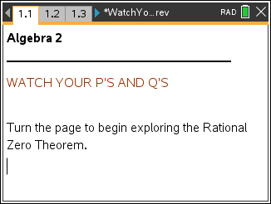  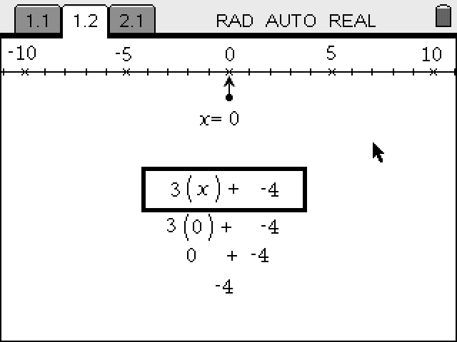
Problem 1: Pages 1.2 to 1.4 on the handheld.  - Page 1.2 introduces the activity.  Write is the Rational Zero Theorem? |  | 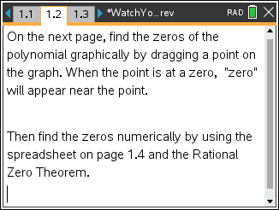
- Move to page 1.3 and locate the zeros of the function by dragging the point on the graph.  What are the zeros? |  | 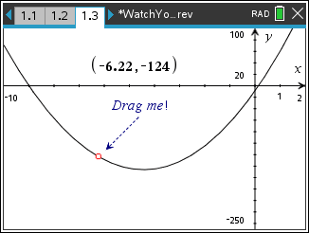
- Move to page 1.4 and use the spreadsheet to find the exact zeros of the function.  What are the exact zeros? |  | 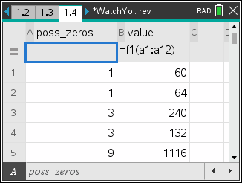

Problem 2: Pages 2.1 to 2.2 on the handheld.  - Drag the point on page 2.1 to locate the zeros of the function.  What are the zeros? | 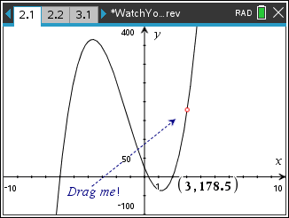
- Move to page 2.2 and identify all of the possible rational zeros using the Rational Zero Theorem and enter the results in the spreadsheet. Use the column labeled value to find the zeros of the function.  What are the zeros? | 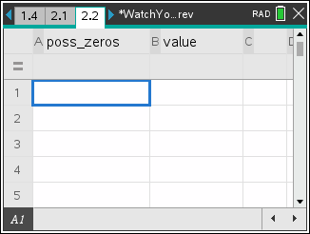
Problem 3: A graphical look at the possible zeros of a parabola.  - Click the slider to change the value of b (which changes the parabola).  How is it possible that the graph sometimes has zeros that do not cross at any of the possible rational zeros that are labeled on the graph? | 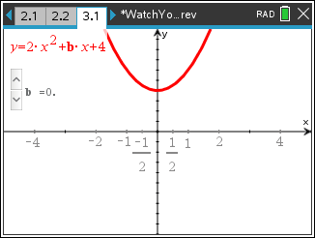
Exercises: You may use pages 4.1 and 4.2 to verify your answers to the exercises below.

- Use the method described in the activity to find the rational zeros for .

- How could synthetic division be used to help find the other zeros for the polynomial in Exercise 1?

Use synthetic division to find the zeros of the polynomial.

- Is it possible for a polynomial to not have any rational zeros? Explain.

Is it possible for a polynomial to no have any zeros at all? Explain.

- An object is launched vertically from a point above the ground at an initial speed of feet per second. Its vertical distance above the ground is given by the equation. Determine how long an object with velocity of 300 ft/sec will stay in the air if thrown upwards from a height of 5 feet.

