Step 1 – Collecting the data
Measure your height and wingspan. Your teacher has instructions for you as to how you will collect and record the data.
After collecting data, it is always important to display the data graphically. Since there are two variables involved, create a scatter plot.  Enter the data in list HEIGH and list WINGS.  1. Which is the independent variable? Why? | 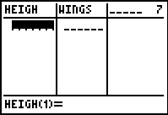
Step 2 – Creating a scatter plot
Create a scatter plot of the data. Press   and make sure the settings for Plot1 are the same as the screenshot at the right.  To graph the data press  and select the ZoomStat option, which adjusts your window settings to fit the data. | 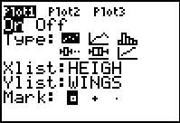
2. Does the data appear to follow a pattern? If so, what is the pattern?

3. Describe the relationship between the two variables using the vocabulary you have learned. Discuss the type of association and strength of the relationship.

Step 3 – Drawing a line of best fit
If the data appears to have a pattern, we can describe the pattern using a mathematical model. In this case, the model would be linear.
4. What properties should this line have?

Draw a line that has these properties.  - Go to the CALC menu by pressing  .  - Choose Manual-Fit.  - Move the cursor to the bottom left of the scatter plot and anchor the point by pressing .  - Move the cursor to the right and upward and press  to anchor the right endpoint. | 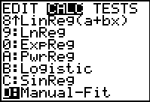
5. Describe your line of best fit. Does it meet the properties that were listed above?

6. The equation for your line of best fit is located in the top-left corner. Record the equation below. How does your equation compare to the equations of other classmates?

