Suppose you randomly select samples from two independent, normally distributed, populations. The distribution of the ratio of the sample variances, , is the F distribution.
Problem 1 – Characteristics of the F Distribution
The notation F(6, 10) is used to represent an F distribution where 6 is the number of degrees of freedom in the numerator and 10 is the number of degrees of freedom in the denominator. For both, the number of degrees of freedom is one less than the sample size.
Press  and set the values equal to the following.  Xmin = 0, Xmax = 8, Xscl = 1, Ymin = 0, Ymax = 0.8, Yscl = 0  Graph the F distribution, F(6, 10): Y1 = Fpdf(X, 6, 10). The Fpdf command is accessed by pressing  . | 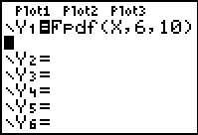
Change the degrees of freedom for one or both samples.
1. How does the F distribution compare to other distributions that you have studied?

Graph two F distributions to determine if the graph changes when the degrees of freedom are interchanged.  2. Does F(df1, df2) = F(df2, df1)? Explain your reasoning. | 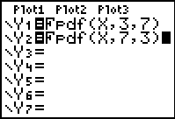
Problem 2 – Probabilities and Percentiles
3. What would be true about the variances of two samples if the ratio of the variances was close to one? Why?

The command Fcdf, found by pressing ú, finds the area under the curve, to the left of a given F value.  The format is (lower bound, upper bound, degrees of freedom in the numerator, degrees of freedom in the denominator).  4. Find P(F < 1) for two samples, where n₁ = 16 and n₂ = 26. | 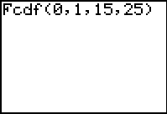
- Press □ and clear any entries.  - Set the window values equal to the following: Xmin = 0, Xmax = 6, Xscl = 1, Ymin = –0.5, Ymax = 1, Yscl = 0.  - Press  , move to the DRAW menu, and select ShadeF(.  - Type 0, 1, 15, 25 inside the parentheses to both calculate and display the area under the graph. | 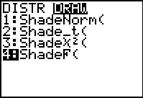
Use the charts located in your Statistics book to answer the following.
- For F(15, 25), what is the F value at the 95th percentile?

Verify your answer by using the ShadeF tool.
Problem 3 – Critical Values for an F Distribution
To construct a confidence interval for a ratio of variances, you must find two critical values: and . The subscripts represent the left and right values. For Questions 6 and 7, confirm the answer using the Fcdf command.
6. Use the charts located in your Statistics book to find F_{R} that would be used for F(6, 10) at the 95% level.

- The value of F_{L} that would be used for F(6, 10) is the reciprocal of F(10, 6). Find this value.

8. Find F_{L} and F_{R} for F(20, 15) at the 98% level.

Problem 4 – Constructing a Confidence Interval
Confidence Interval for Ratio of Variances
A factory manager compares the means and standard deviations of weights of random samples of items produced on both an old and new machine.
Old machine: n = 37, g, and s = 6.7 g
New machine: n = 44, g, and s = 4.1 g
9. Construct a 95% confidence interval for the ratio of the variances.

10. Do you think that the weights of the items produced by both machines have the same standard deviation? Why or why not?

