Part 1 – Draining a Water Tank
In this problem, a water tank is being drained by two pipes. Use the following information to set up one way to solve this particular problem.
One pipe drains at a rate of 50 liters per minute faster than the other pipe. If the pipes release 4,700 liters in 10 minutes, what is the drainage rate?
1. Translate the word problem above to a verbal sentence using variables.

2. Together, what is the unit rate that water drains from the tank? l/min
3. Enter the combined expression for the rate the water drains in Y1. Enter the unit rate in Y2. To access Y1, press !.  What are these expressions?  Y1 =  Y2 = | 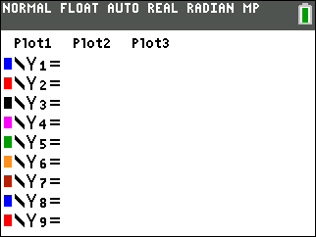
4. Write an equation where the left side is Y1 and the right side is Y2.

5. What value of x will make the left side of this equation equal to 470?
One way to answer this question is to use tables to determine the correct value for x.  Set up the table by pressing ` ç. Starting at zero and incrementing by 50 is a good start. | 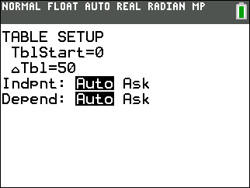
6. Use ▲ and ▼ to scroll through the table looking for when Y1 is equal to Y2. What do you find?

7. Adjust the table values as needed to find an exact answer. What value makes the two sides equal?
8. At what rate does each pipe drain? Pipe 1: _________________ Pipe 2:
Part 2 – Solving by a Different Method
9. Another way to solve this equation is by looking at a graph. You have already entered the left and right side in Y1 and Y2. The point on the graph you are interested in is where the two lines intersect. Press @ to adjust the viewing window to an appropriate setting. Then press %.
Use the Trace feature ($) to find the intersection point.
Are you able to find the exact intersection for the lines?
If not, adjust the Window settings to allow you to find the exact intersection point. Press @ and adjust the various values, including Xscl, until you can.
10. Draw your graphs on the screen at the right and indicate the intersection point. | 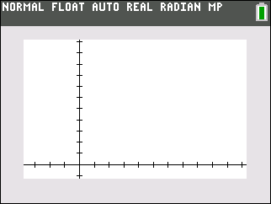
Part 3: Using the Solver
11. Finally, use the SOLVER to find a numerical solution to the equation. To access the solver, press m and select B:Solver….  Enter the left side of the equation in the E1 box and the right side of the equation in the E2 box.  Press OK or e when done. | 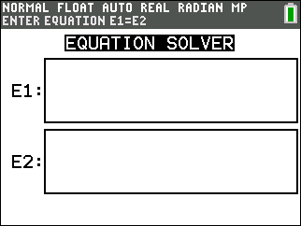
12. Place the blinking cursor over the value of X. Press a ∑. What value is returned for x?
13. How does this value compare to the value you found as the intersection of the graphs?

14. How does this value compare to the value you found using the table?

15. What are the advantages or disadvantages to the different ways of solving equations?

