Open the TI-Nspire document Area_Function_Problems.tns.  Objective: To extend the understanding of the relationship between the area under a derivative curve and the antiderivative function.  Directions: For each problem, drag the empty circle on the x-axis and watch point P move across the graph. Next, move to page 2 of the problem and use f2(x) to type the function you think point P is modeling. Determine if your function matches the scatter plot of the area function. | 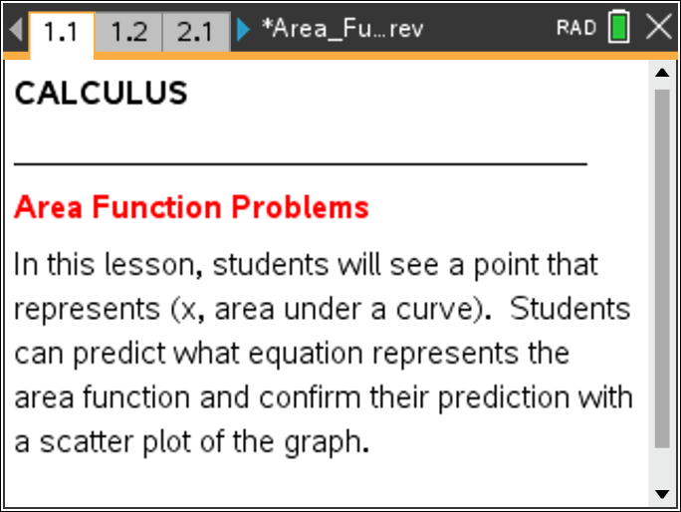

Move to page 2.1. | Press / ¢ and / ¡ to navigate through the lesson.
Record your antiderivative function for each problem.

Problem 2:

Problem 3:

Problem 4:

Problem 5:

Problem 6:

Problem 7:

Problem 8:

Use the results from the activity to answer the questions.

1. What is the antiderivative function of f(x) = –2?

2. What is the antiderivative function of f(x) = k?

3. What is the antiderivative function of f(x) = mx + b?

4. What is the difference between the antiderivative function of problem 4 and that of problem 6?

5. Why is the area negative when the left endpoint is in the first quadrant?

6. When does moving the left endpoint further to the left make the total area positive?

7. What is the difference between the antiderivative function of problem 6 and that of problem 8?

