Problem 1 – Chirps in 15 Seconds vs. Temperature
When looking at data, it is often difficult to see a relationship. However, when the data is plotted, a trend becomes clear. While real data rarely matches an equation perfectly, a line of best fit can be plotted to make predictions for future values.
Step 1: Run the program SCATTER and choose the first option 1: CHIRPS.  Look at the data of temperature, L1, (in °F) and the number of cricket chirps in 15 seconds, L2, in the Stat Editor by pressing  . | 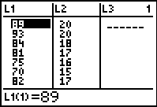
- Is it easy to see a relationship between chirps and temperature by only looking at the data? Why or why not?
Step 2: Sometimes it is easier to see a relationship by observing a scatter plot of the data. To create a scatter plot, press    and match the screen to the right.  Now press  and select ZoomStat to observe the scatter plot. | 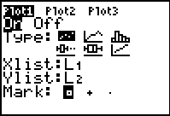
Step 3: To manually draw a line of best fit, press   and select Line(.  A cursor will appear in the middle of the screen. Use the arrow keys to place the first point near the start of the data. Press  and record the coordinates to the nearest whole number below.  Point 1: x:________ y: ________ | 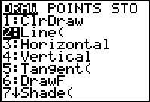
Move your cursor to the end of the data. Press e and record these coordinates.  Point 2: x: ________ y: ________  The line should pass between most of the data. | 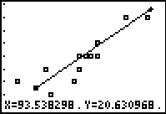
- On the Home screen, use Points 1 and 2 to write an equation for your line.
Step 4: Press □ and enter your equation next to Y1. Press  to verify that it passes through the data. | 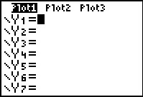
- Using the equation of your line of best fit, predict the number of chirps in 15 seconds you would expect to hear if the temperature was 100°F. How many chirps for 55°F?
Problem 2 – Olympic High Jump
Step 5: Run the program SCATTER and choose the second option 2: HIGH JUMP.  Look at the data of years, L1, and the winning men’s Olympic high jump height, L2, in the Stat Editor. | 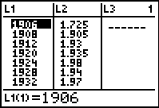
- By only looking at the data of high jump height for each year, can you see a general trend? Why or why not?
Step 6: Repeat the procedure for putting in a manual line of best fit as before.

Point 1: x:________ y: ________
Point 2: x:________ y: ________
- What is the equation of your line?

- Use this equation to predict the height of the high jump for the 2012 Olympics.

- Looking back at the data since 1988, does your prediction for the 2012 games seem realistic and reasonable? Why or why not?

Problem 3 – Brain Size and IQ
Step 8: Run the program SCATTER and choose the third option 3: BRAIN SIZE.  Look at the data of IQ, L1, and the brain size, L2, in the Stat Editor.  Step 9: Create the scatter plot. | 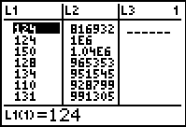
- By looking at the graph of Brain Size vs. IQ, does there appear to be a relationship between brain size and IQ? Change the variables on the axis. Does a relationship appear?

Extension
Problem 1 – Women’s Olympic Discus Throw
Run the program SCATTER and choose the fourth option 4: DISCUS. Look at the data of years, L1, and the distance of the discus throw, L2, in the Stat Editor.
- Find the equation of the line of best fit. Make a prediction for a future Olympic year and discuss its reasonableness.

Problem 2 – How many handshakes?
Below is a diagram of 3 and then 4 people in the room. If each person were to shake hands with every other person, how many handshakes would there be?

- Draw below what this would look like if there were 5 people in the room. How many handshakes would there be, if there were 6 people?

Using the graphing calculator, store the number of people in L1 and the number of handshakes in L2.
- After creating the scatter plot, does this data look linear? What is the shape of this graph?

