Math Objectives  - Students will construct and interpret box plots and histograms of data to draw informal comparisons about two populations. Students will compare using medians, quartiles, maximums, minimums, ranges, interquartile ranges, and shapes and clustering patterns found in distributions.  - Students will informally assess the degree of visual overlap of two numerical data distributions with similar variabilities, measuring the difference between the centers by expressing it as a multiple of a measure of variability (CCSS).  - Students will reason abstractly and quantitatively (CCSS Mathematical Practice).  - Students will construct viable arguments and critique the reasoning of others (CCSS Mathematical Practice).  Vocabulary  - box plot • lower and upper Quartiles • outlier  - histogram • Interquartile Range (IQR) • bin width  - mean  About the Lesson  - This lesson involves drawing informal comparative inferences about two populations.  - As a result, students will:  - Construct the box plots and histograms to informally compare two samples of data.  - Compare the bench press strengths of seventh and eighth grade males, the heights of seventh and eighth grade females, and the shuttle times of seventh and eighth grade males with a focus on medians, quartiles, minimums, maximums, and the shapes of distributions.  - Compute, by hand, the five number summaries without technology and then confirm using technology.  TI-Nspire™ Navigator™  - Collect and Send files.  - Class Capture.  - Quick Poll.  - Live Presenter.  Activity Materials  - Compatible TI Technologies: + TI-Nspire™ CX Handhelds,  + TI-Nspire™ Apps for iPad®,  + TI-Nspire™ Software | 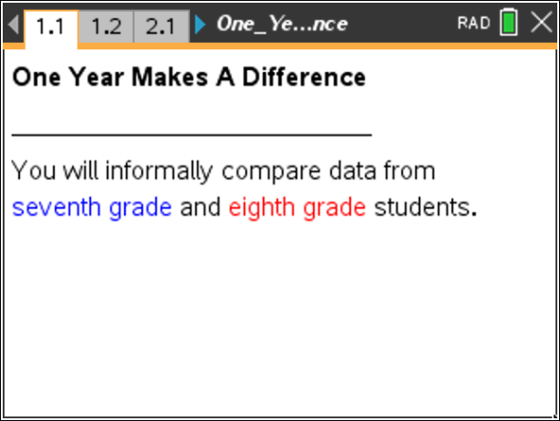  Tech Tips  - This activity includes screen captures taken from the TI-Nspire™ CX handheld. It is also appropriate for use with the TI-Nspire family of products including TI-Nspire software and TI-Nspire App. Slight variations to these directions may be required if using other technologies besides the handheld.  - Watch for additional Tech Tips throughout the activity for the specific technology you are using.  - Access free tutorials at http://education.ti.com/calculators/pd/US/Online-Learning/Tutorials  Lesson Files:  Student Activity  - One_Year_Makes_A_Difference_Student.pdf  - One_Year_Makes_A_Difference_Student.doc  TI-Nspire documents  - One_Year_Makes_A_Difference.tns  - One_Year_Makes_A_Difference_Assessment.tns
Discussion Points and Possible Answers

1. The table below shows bench press strengths of 20 seventh grade male students and twenty eighth grade male students collected at the beginning of a strength-training unit in Physical Education. Does this data suggest any differences in the seventh and eighth grades? Compute and compare the minimums, medians, and maximums to support your answer.

7th Grade  Bench Press (lbs) |  |  |  | 8th Grade  Bench Press (lbs)
84 | 98 | 112 | 120 | 82 | 106 | 116 | 126
88 | 98 | 114 | 120 | 94 | 106 | 122 | 126
90 | 102 | 116 | 124 | 98 | 110 | 124 | 128
94 | 104 | 118 | 124 | 100 | 110 | 124 | 136
94 | 108 | 118 | 132 | 104 | 112 | 124 | 162

Answer: The minimum bench press for the 7th grade is 84 lbs and the minimum bench press for the 8th grade is 82 lbs. The medians are 110 lbs and 114 lbs for the 7th and 8th grades, respectively. The maximums are 132 lbs and 162 lbs for the 7th and 8th grades, respectively.

Move to page 1.2.  2. The variables grade8_bp and grade7_bp are stored in this document, so you can select them to be plotted on the coordinate axes. To display a box plot, follow these steps:  - Select the add variable text at the bottom of the page, and select the variable grade7_bp. | 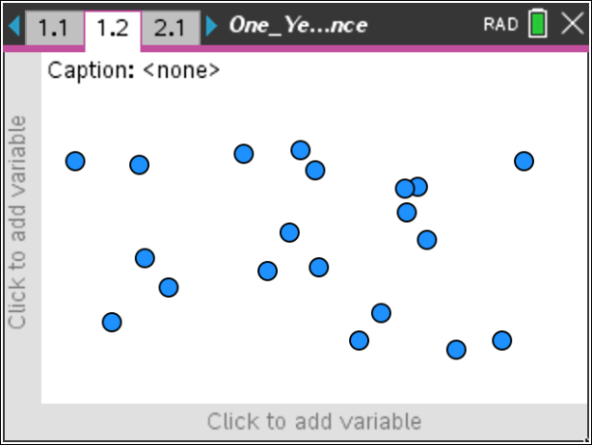
- Select MENU > Plot Properties > Add X Variable and select the variable grade8_bp.  - Select MENU > Plot Type > Box Plot.  - Move the cursor over each part of the box plots to reveal the values for the five number summaries. | 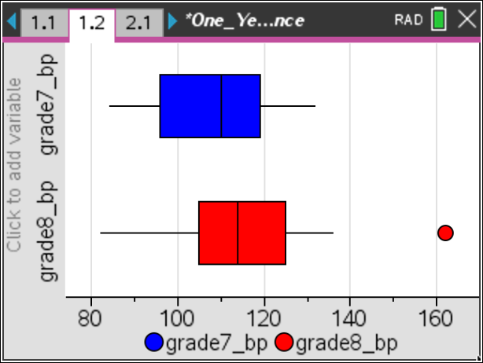
Tech Tip: Tap the add variable text box on the x axis and then select the variable grade7_bp. Select  > Plot Properties > Add X Variable and select the variable grade8_bp. Then create the box plot by selecting > Plot Type > Box Plot. > Plot Properties > Extend Box Plot Whiskers can also be selected.
Teacher Tip: Remind students that a box plot can be used to visualize and compare the distributions of two sets of data. The box plot allows you to get a snapshot of five key features of a set of data. You see the minimum value, the lower quartile, the median, the upper quartile, and the maximum value displayed. These are often called the five number summaries.
3. Explore the box plots, and answer the following questions:
a. Find the five number summaries for the data sets and record them in the table below.

Answer:

Grade | Minimum  (lbs) | Lower Quartile  (lbs) | Median  (lbs) | Upper Quartile  (lbs) | Maximum  (lbs)
7th | 84 | 96 | 110 | 119 | 132
8th | 82 | 105 | 114 | 125 | 162

b. Describe the similarities and differences in the five number summaries and the box plots.

Answer: The minimums are nearly the same while the lower quartiles differ by 9. The median of the eighth-grade data set is slightly larger than the seventh-grade median, and the upper quartiles differ by 6. The differences in the maximums values favor the eighth grade by 30 pounds and the maximum value for the eighth grade is an outlier. The box plots look somewhat similar; the boxes are about the same size but the left whisker for the 8th grade is longer.

c. Describe any differences you find between the 7th grade and 8th grade data using the five number summaries and the box plots.

Answer: Because four of the five statistics show the eighth-grade students have greater bench press strength, it appears that there is a difference in the data sets when you compare visually using box plots and when you examine the values in the five number summaries.

Teacher Tip: Discuss with the students the overall changes that can be seen when comparing each of the five number summaries individually and as sets. It is possible there might be changes in a few of the summary statistics, but no substantial differences might exist between two data sets. If there are several differences in the statistics and those differences are large, then there is likely to be a substantial difference in the data sets.

4. Suggest other plots that could be used to compare these sets of data.

Answer: Histograms

Teacher Tip: Remind students that a histogram can be used to visualize and compare the distributions of two sets of data. A histogram consists of tabular frequencies, shown as adjacent rectangles constructed over discrete intervals. These intervals are often called bins. The histogram allows you to get a snapshot of the number of values in each discrete interval and to see clusters and gaps in a set of data. You can see the minimum value and the maximum value displayed as well as the frequency for each interval.

5. Change the Box Plot to a Histogram by selecting MENU > Plot Type > Histogram. | 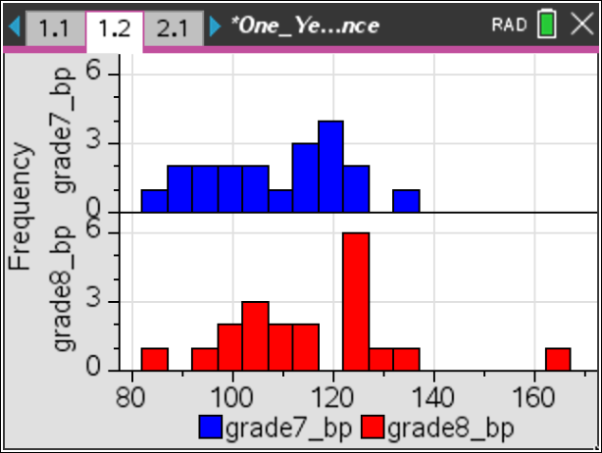
Tech Tip: Change the Box Plot to a Histogram by selecting > Plot Type > Histogram. Note that in some cases, a student may need to back-out to the main Tools Menu to see the desired menu option.
6. Describe the histograms. What are the most frequent intervals for each data set? What are the overall shapes and positions of the distributions? Explain your reasoning.

Sample Answer: The most frequent interval for the seventh grade is 117 - 122 while the most common interval for the eighth grade is 122 – 127. The distributions both appear to be similar in shape, but the eighth-grade bench press distribution is to the right (larger values) of the seventh-grade distribution.

Teacher Tip: This is a good place to have a discussion that the box plot and histogram provide different views of the data sets. Ask them which one provides them with more information to tell if there are sizeable differences in the data sets. Discuss the advantages of each graphic organizer.

TI-Nspire Navigator Opportunity: Quick Poll
See Note 1 at the end of this lesson
Move to page 2.1.  7. Do you think that young women grow much between the start of seventh grade and the start of eighth grade? The table below contains the heights in inches measured at the start of each school year. Recall the interquartile range (IQR) is the difference between the upper and lower quartile while the range is the difference between the maximum value and minimum values of a data set. | 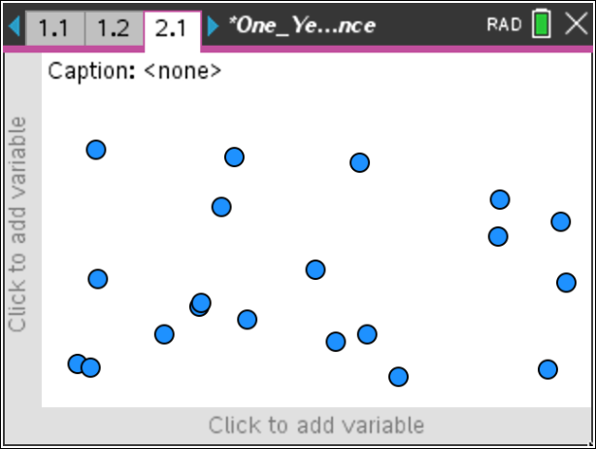
Seventh Grade  Height (in.) |  |  |  | Eighth Grade  Height (in.)
55 | 56 | 61 | 65 | 59 | 64 | 66 | 67
56 | 57 | 61 | 65 | 60 | 64 | 67 | 68
56 | 57 | 63 | 65 | 60 | 65 | 67 | 69
56 | 57 | 63 | 67 | 61 | 65 | 67 | 69
56 | 59 | 63 | 67 | 62 | 65 | 67 | 69

a. Compute the five number summary, the interquartile range, and the range for each data set, and record them below.

Grade | Minimum | Lower Quartile | Median | Upper Quartile | Maximum | Interquartile Range | Range
7th | 55 | 56 | 60 | 64 | 67 | 8 | 12
8th | 59 | 63 | 65.5 | 67 | 69 | 4 | 10

b. Does this data suggest that there is a difference between the heights? Support your answer using the data found in the table.

Sample Answer: The data suggests that eighth graders are taller, but the differences in heights are between 2 – 4 inches.

8. Create box plots for the data as before, and verify the computations for the five number summaries, the interquartile ranges, and the ranges. What does the box plot show, if anything, that the computed statistics did not? Explain.  Answer: It seems all of the five number summary values are different with the eighth grade exceeding the seventh grade. The lower quartiles had the greatest difference. The box plots show differences with the eighth-grade data distribution shifted to the right showing greater values than the seventh-grade data. | 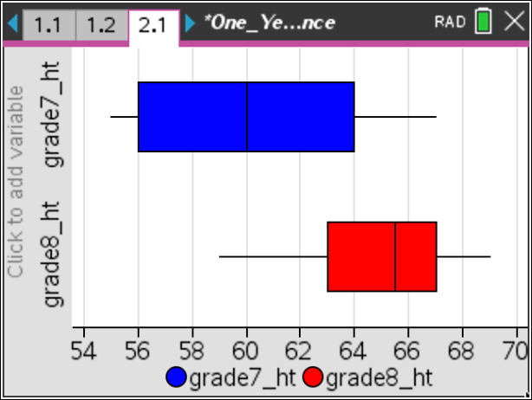
9. Now construct and describe the histograms for these data sets. Compare the shapes of the histograms. Are there gaps or clusters? Explain your reasoning.  Sample Answer: Neither of the shapes are mound shapes, but the data for the seventh grade is more evenly spread. There are a few gaps and one cluster in the seventh-grade histogram. The eighth-grade histogram has one gap and two clusters. | 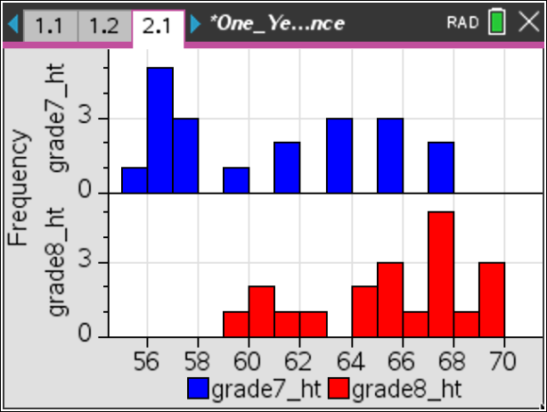
TI-Nspire Navigator Opportunity: Quick Poll
See Note 1 at the end of this lesson
Teacher Tip: This is another good place to have a discussion that the box plot and histogram provide different views of the data sets. Ask students if the differences in the medians can be seen in the histograms.

Move to page 3.1.  10. Do you think that young men get much faster between the start of seventh and the start of eighth grade? The table below contains the shuttle run times in seconds measured at the start of each school year. | 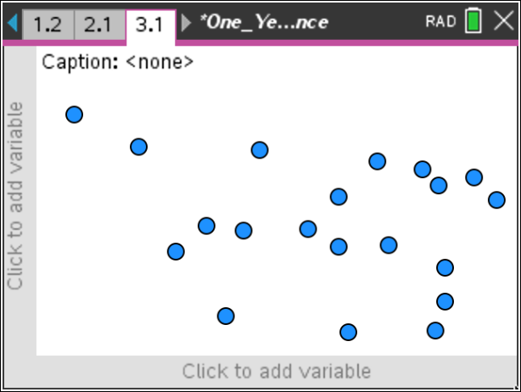
Seventh Grade  Shuttle Run (sec) |  |  |  | Eighth Grade  Shuttle Run (sec)
6.0 | 7.9 | 9.0 | 12.9 | 6.3 | 7.3 | 8.2 | 9.0
6.3 | 8.1 | 9.3 | 13.1 | 6.5 | 7.7 | 8.4 | 9.3
7.0 | 8.1 | 10.0 | 13.6 | 7 | 8.0 | 8.5 | 9.6
7.1 | 8.2 | 11.7 | 13.6 | 7.1 | 8.1 | 8.6 | 10.
7.5 | 8.8 | 12.3 | 14.2 | 7.3 | 8.1 | 9.0 | 10.5

a. Compute the five number summary, the interquartile range, and the range for each data set, and record them below.

Grade | Minimum | Lower Quartile | Median | Upper Quartile | Maximum | Interquartile Range | Range
7th | 6.0 | 7.7 | 8.9 | 12.6 | 14.2 | 4.9 | 8.2
8th | 6.3 | 7.3 | 8.15 | 9.0 | 10.5 | 1.7 | 4.2

b. Does this data suggest that there is a difference between the times? Support your answer using the data in the table and the relative sizes of the interquartile ranges and the ranges.

Sample Answer: The data suggests that eighth graders are faster, but the differences in speed are slight. The eighth grade is bunched more tightly. The IQR of the eighth grade is about 1/3 of the IQR of the seventh grade. The range of the eighth grade is about ½ of the range of the seventh grade.

11. Create box plots for the data, and verify the computations for the five number summaries, the interquartile ranges, and the ranges. What does the box plot show, if anything, that the computed statistics did not? Explain. | 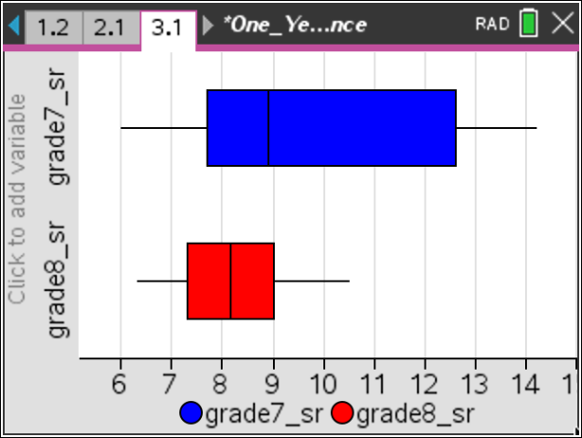
Answer: The box plots show differences except for the medians and upper quartiles. The median shifted and the upper quartile changed more than the other statistics changed. About ¾ of the 8th grade is faster than ½ of the seventh grade.
12. Create the histograms, and then describe them. Compare the shapes of the histograms. Are there gaps or clusters? Explain your reasoning.  Sample Answer: The eighth-grade data has a mound shape, but the data for the seventh grade spreads out into three clusters. There are three gaps in the seventh-grade histogram. The eighth-grade histogram has no gaps and is clustered more in the middle. | 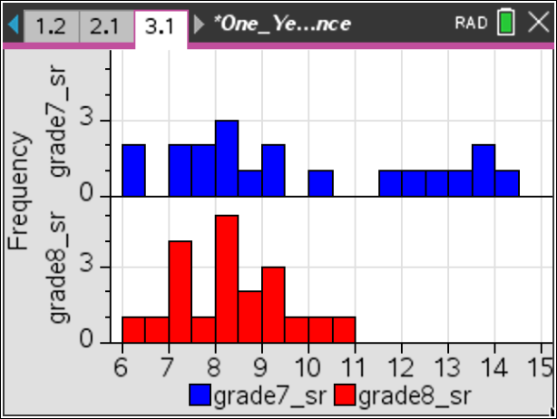
TI-Nspire Navigator Opportunity: Quick Poll
See Note 1 at the end of this lesson
13. Adjust the bin widths of the histograms by selecting MENU > Plot Properties > Histogram Properties > Bin Settings > Equal Bin Width. Change the bin width to 0.25. What is the impact on gaps and clusters?  Answer: Now there are more gaps in both histograms. | 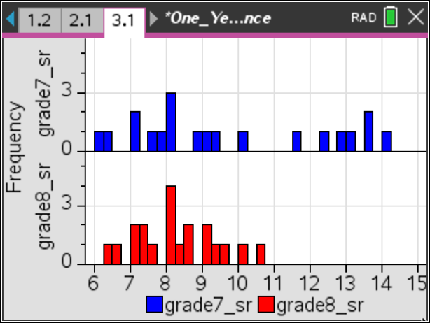
Tech Tip: Adjust the bin widths of the histograms by selecting > Plot Properties > Histogram Properties > Bin Settings > Equal Bin Width. Then select the cell for “Width” and type in 0.25.
Teacher Tip: Discuss with students that histograms can tell different stories when the bin width is manipulated. If the intervals are narrow, then there might be several gaps; yet if the intervals are wide, the gaps disappear, and clusters develop.

TI-Nspire Navigator Opportunity: Class Capture
See Note 2 at the end of this lesson
TI-Nspire Navigator Opportunity: Live Presenter
See Note 3 at the end of this lesson

Wrap Up
Upon completion of the lesson, the teacher should ensure that students are able to understand:
- How to construct box plots and histograms using the TI-Nspire for various sets of data.
- Any differences between five number summaries, ranges, and interquartile ranges in two box plots.
- Any differences between two histograms relative to gaps, clusters, and distribution shapes when bin widths are changed.
- How to compare the information gained from a box plot and a histogram.

Assessment
Use the provided TI-Nspire assessment document that has three multiple-choice questions to assess student understanding of the major concepts of this lesson. Some of the questions have more than one correct answer.

Explanations for the answers:

Question 1:
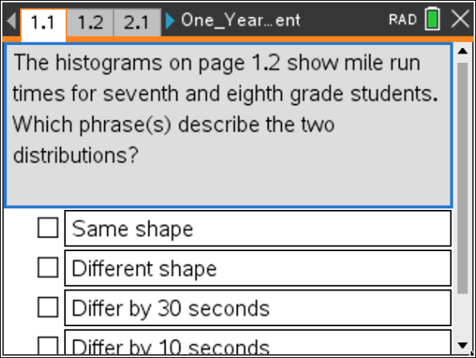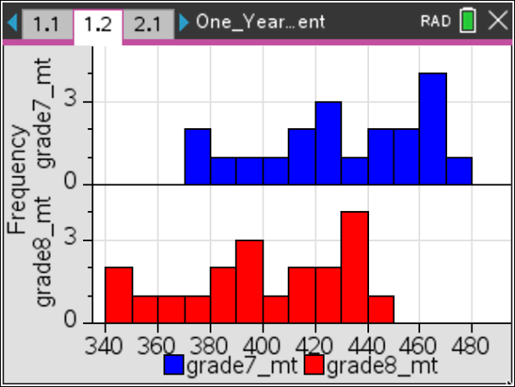

The variables have a very similar distribution, but the seventh grades students are about 30 seconds slower.

Question 2:
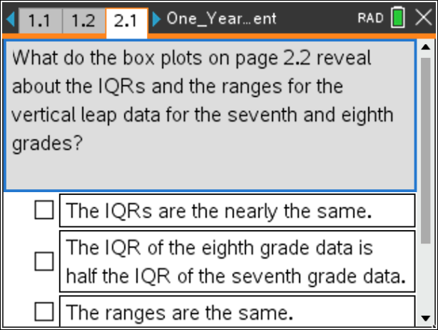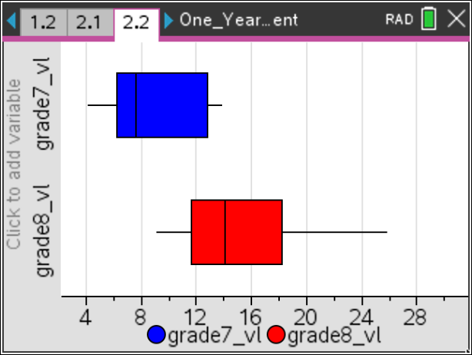

The box plots reveal that the range of the eighth-grade data is nearly twice that of the seventh-grade data, and the IQR values are nearly equal.

Question 3:
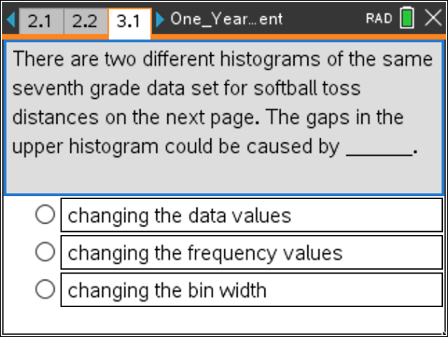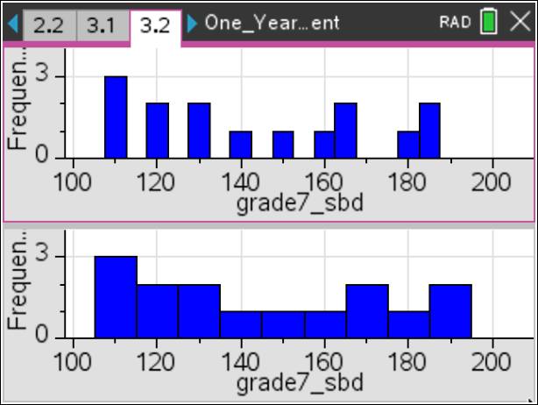

The gaps are a result of the narrower bin widths.
TI-Nspire Navigator

Note 1
Question 6, Quick Poll
After students construct box plots and histograms, discuss questions using the True/False or Yes/No option in Quick Poll to collect student answers to questions 3, 6, 8, 9, and 10. You can ask True/False questions like: “Are the five number summary values the same? Are there gaps? Are there clusters?

Note 2
Question 13, Class Capture
Use Class Capture to display box plots and histograms created by the students and let students compare them. It is important that students realize that changing bin widths and window values can have a dramatic impact on these plots.

Note 3
Question 13, Live Presenter
Use Live Presenter for students to explain and show any gaps, clusters, and the five number summary values. Students can move their cursors over the plots to display values.

