Angles Formed by Two Intersecting Lines

Introduction
Intersecting lines are one of the most common figures in geometry. In this activity, you will investigate the properties of angles formed by intersecting lines. The outcome of the activity will produce two important geometric theorems dealing with vertical and supplementary angles.

This activity makes use of the following definitions:

adjacent angles: two angles with a common vertex and a common side, but no common interior points.
supplementary angles: two angles that have measures that sum to 180°.
vertical angles: two non-adjacent angles formed by two intersecting lines.

Part 1 – Intersecting Lines and Vertical Angles
Either your teacher will give you directions to create the Cabri Jr. file ILAVA.8xv or send the file directly to your calculator. Once you have the file ILAVA, proceed to Part 2.

Part 2 – Exploration

Open the Cabri Jr. App by pressing A, then scroll down to Cabri Jr. and press e. Press any key to start the APP. Open the File ILAVA by pressing ! to access the F1 menu. Highlight Open and press e. | 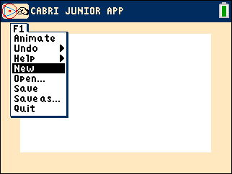
Highlight the file ILAVA and press e to open. | 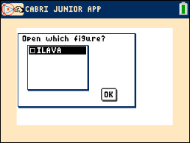
Make sure that all angle measures are included in the diagram. If they are not, measure the remaining angles using the F5 menu. Press % for F5, scroll down to Measure, then scroll to Angle and press e. | 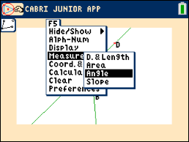

Part 3 – Questions and Conjectures
- Identify all pairs of vertical angles and make conjectures about their measurements.

- Identify all pairs of adjacent angles and make conjectures about their measurements.

3. If m∠DEB is 90°, what would be the measure of the remaining angles? Verify your answer using the construction. Write a conjecture about two lines that intersect at a 90° angle.

4. Find the measures of the remaining angles in the diagram at the right. | 