Open the TI-Nspire document Watch_the_Birdie_Breathe.tns  In this activity, you will analyze data in a spreadsheet and graph to explore the relationship between the outside temperature and the amount of oxygen a bird uses. | 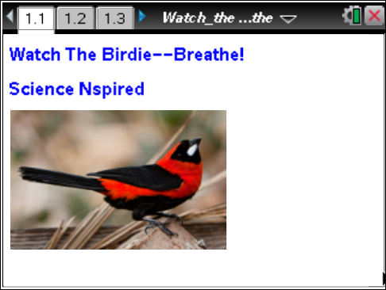

Birds and mammals are very unique critters! They are like reptiles, amphibians, and fish in a lot of ways. But they have one characteristic that sets them apart from all other animals—they are “warm-blooded”. The technical word for warm-blooded is endothermic, which means “inside” (endo-) “heat” (-therm). | Press / ¢ and / ¡ to navigate through the lesson.
YOU are an endotherm! You regulate your body heat inside yourself, and you work very hard to keep your body heat at a constant temperature. On the other hand, ectotherms, or “cold-blooded” animals, largely depend on the heat in their environment to keep their bodies warm. Fish, amphibians, and reptiles are ectotherms. Being an endotherm has its advantages, but there is a price to pay. As you look at the data in this activity and answer the questions, think about what this price is and how endotherms deal with it.
Move to page 1.2.  1. Review the data in the spreadsheet. The temperatures represent the environmental temperatures in degrees Celsius and the oxygen used data is in mL/g of body weight/hour for a small bird, such as a sparrow. Note that the first four temperatures are negative values. | 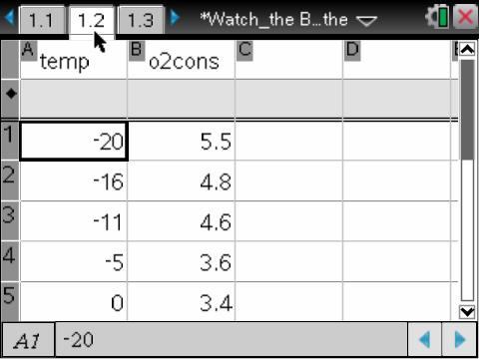
Move to page 1.3.  2. Review the scatter plot. Generate a line of best fit for the data. Press Menu > Analyze > Regression > Show Linear (mx+b). | 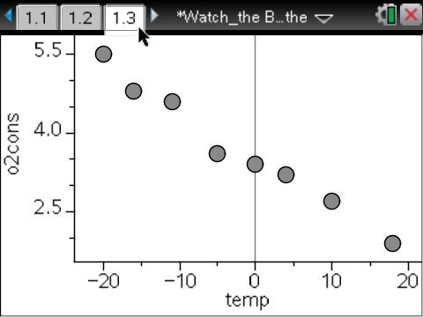
Move to page 1.4. Use the data to help answer the following questions here or in the .tns file.
Q1. Write the equation for your line of best fit: _________________________

Q2. What is the rate of change (slope) of the relationship between temperature and oxygen consumption? Make sure you label the rate with units.
Q3. Which variable is the independent variable in the graph, temperature or oxygen consumption?

Q4. Which variable is the dependent variable in the graph?

Q5. Describe the appearance of the graph.

Q6. What is the relationship between temperature and oxygen consumption?

Q7. What is the source of the heat that an endotherm generates?

Q8. The colder it gets, the more oxygen the bird uses. What is the process the bird uses to consume the oxygen that it inhales?

Q9. When would a bird need to eat more, in the summer or in the winter? Explain.

Q10. What are a bird’s “choices” for finding and consuming food when the weather gets really cold?

Q11. Why does a bird’s oxygen consumption decrease as temperature increases?

Q12. What label should be attached to the rate of change (slope) in this problem? Describe what the rate of change means in the context of this problem.

Q13. If the data in the original data table is from observations of a small bird like a sparrow or a robin, predict how the data would differ for a much larger bird, such as a bald eagle.

Q14. Predict which birds, small birds or large birds, would need to eat more food per gram of body mass. Explain.

Q15. How do you predict the data and graph would be different if you were analyzing oxygen consumption for an ectothermic (cold-blooded) animal, such as a lizard or a turtle?

