Open the TI-Nspire document Similar_Figures.tns.  This activity allows you to manipulate figures to establish a relationship between two rectangles or two triangles. | 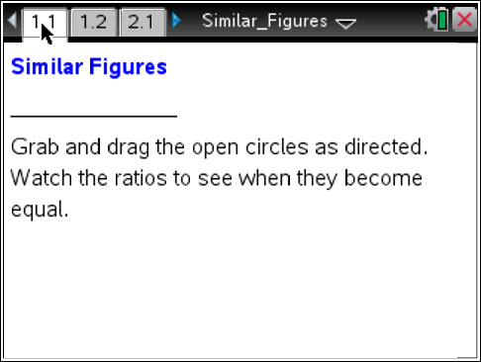

Move to page 1.2.
1. Drag the two open circles on the bottom rectangle.
  - What happens to the figures?

  - What do the numbers in the ratios represent?

- Drag the two open circles until the ratios are equal but the rectangles are not congruent. Describe how the bottom rectangle is related to the top rectangle.

- Drag the open circles on the bottom rectangle to find three other rectangles whose side lengths have a ratio equal to . Record the side lengths and ratios in the table below.
 | Short Side | Long Side | Ratio
Top Rectangle | 2 | 6 | 2:6
Rectangle 1
Rectangle 2
Rectangle 3

- Two figures are similar if and only if the ratios of all pairs of corresponding sides are equal and all corresponding angles are congruent. Are any of the rectangles above similar? Tell how you know.

5. Susie drew a rectangle on her paper with side AB equal to 12 units and side BD equal to 45 units. Find the dimensions of two rectangles that are similar to this one.
6. Are all rectangles similar? Why or why not?

Move to page 2.1.
7. How would you know if the two triangles are similar?

8. Drag the open circles at points I and L.
  - What happens to the figures?

  - What happens to the angle measures?

  - What happens to the numbers in the ratios?

9. Drag the open circles at points I and L until all three ratios are equal to each other (but not equal to 1).
a. What do the numbers in the ratios represent?

b. What is the same about the two triangles?

10. a. Are these two triangles similar? Explain.

b. Use page 2.1 in your .tns file to create another triangle similar to the given triangle. Sketch and label the two triangles. Explain why the two triangles are similar.

11. Are all triangles similar?

- Some people say the definition of two similar figures could be: Two similar figures are two figures that have the same shape and different size. Is this a good definition? Explain your reasoning.

