Open the TI-Nspire document Where_is_the_Heat.tns.
Have you ever wondered why ice cools lemonade? Do you know why steam causes a more severe burn than boiling water? Do you know why citrus growers spray their orchards with water if there is danger of a freeze? In this activity, you’ll use a simulation to explore these questions.

Matter is generally considered to exist in three states: solid, liquid, and gas. The particles that make up matter are in continual motion. This motion varies from vibrations in a more or less fixed position (solid), to sliding over one another (liquid), to freely moving in all directions (gas). At absolute zero (–273ºC or 0 K), matter has its lowest kinetic energy.
Move to pages 1.2 – 1.4. Answer the following questions here or in the .tns file.
Q1. Matter is usually considered to exist in one of _________ state(s).
A. one  B. two |  |  | C. three  D. five
Q2. All molecular motion is believed to stop at _________.
A. 0°C  B. 0°F |  |  | C. 0 K
Q3. The atoms of which state of matter rest in relatively fixed positions?
A. plasma  B. gas |  |  | C. liquid  D. solid
Move to pages 2.1 and 2.2.
Each of the three experiments in this simulation has a different temperature scale. The model shows the general way in which the state of most substances changes with temperature. However, not all substances change from solid to liquid to gas. Some (for example, moth balls) change directly from a solid to a gas, which is called sublimation.
1. Choose Experiment 1 by using the lower up/down arrows until experiment 1 appears (if it is not already chosen).  2. Then, use the upper arrow on the time slider to add heat to the sample. Increasing the time increases the energy added to the substance and shows the related behavior of the particles. |  |  |  |  | 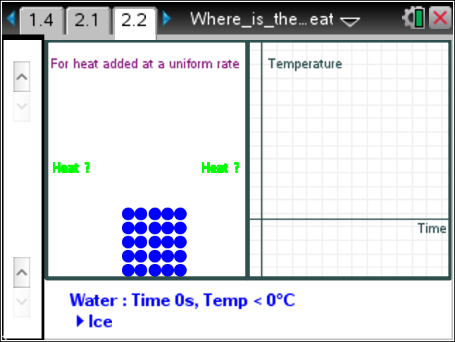
3. Find the melting point (when the matter changes from solid to liquid) and record in the data table on page 2.2.
4. Find and record the boiling point (when the matter changes from liquid to a gas).
5. Find and record the heat of fusion for ice (energy per mol needed to change from solid to liquid).
6. Find and record the heat of vaporization for water (energy per mol to change from liquid to gas).
7. Complete the table for Experiment 2 and Experiment 3 following the same steps.
Data Table
Data | Experiment 1 (HOH) |  | Experiment 2 (C₂H₅OH) |  |  | Experiment 3 (Fe)
Melting point
Boiling point
Heat of Fusion
Heat of Vaporization
Move to pages 3.1–3.6. Answer the following questions here or in the .tns file.
Q4. The melting point for the substance in Experiment 2 is _________.
A. –114°C  B. 0°C |  |  | C. 78°C  D. 1535°C
Q5. The boiling point for the substance in Experiment 2 is _________.
A. –114°C  B. 0°C |  | C. 100°C  D. 78°C |  | E. 1535°C
Q6. When the temperature is –273°C, the particles of a substance _________.

Q7. As temperature increases, the amount of movement of the particles increases.
A. always |  | B. sometimes |  | C. never
Q8. In the liquid state, most of the movement of the particles is __________.
A. horizontal  B. vertical |  |  | C. the same in all directions  D. vibratory
Q9. How does the temperature change during any change of state? Explain.

