Problem 1 – Testing a Formula
A triangle can be represented as a matrix , where (x_{n}, y_{n}) is a vertex of the triangle.
Therefore, the area of the triangle is given by .
Note that the straight lines of the matrix indicate that you should calculate the determinant of the matrix.
Use this formula to find the area of the right triangle shown.  In order to do this, you will need to utilize the matrix functions of the calculator. These functions are accessed by pressing y —.  To enter the matrix into the calculator, arrow over to the EDIT menu and choose any listed matrix (labeled [A], [B], etc.). Choose [A]. | 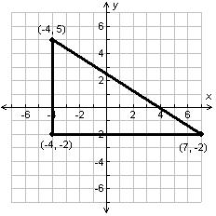
Now the dimensions (row x column) need to be entered, along with the values of each cell. Press Í to move from cell to cell.  When the matrix is finished being entered, press y z. | 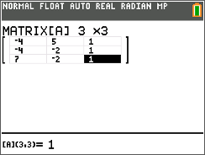
The det command can be found under the MATH menu of the matrix functions.  Now, to find , return to the Home screen. Enter the expression 0.5det([A]) as shown on the right. | 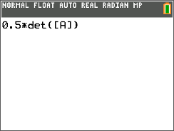
1. What is the area of the triangle using the matrix method?

2. Check the answer to question 1 by finding the area of the triangle using the geometry formula .

3. Why do you think that ± is needed in the matrix method?

Problem 2 – Practice Problems
4. Find the area of the triangle to the right using matrices.  5. Check the calculated area by using geometric formulas or by estimating the number of squares inside of the triangle. |  | 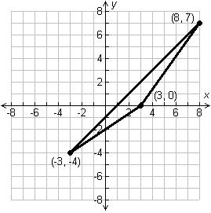
6. Find the area of the triangle to the right using matrices.  7. Check the calculated area by using geometric formulas or by estimating the number of squares inside of the triangle. |  | 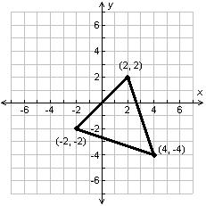
Extension – Fencing a Garden
8. A gardener is trying to find a triangular area behind his house that encloses 1750 square feet. He has placed the first two fence posts at (0, 50) and (40, 0). The final fence post is on the property line at y = 100. Find the point where the gardener can place the final fence post. |  | 