Open the TI-Nspire document Blocking_Introduction.tns.  In this activity, you will investigate the effectiveness of two mosquito sprays in a large tract of land by using two different experimental designs—one randomized design and one randomized block design. | 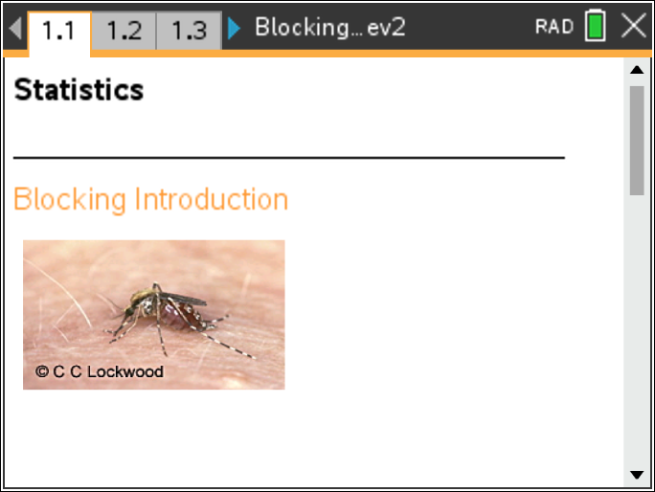

Move to page 1.2. | Press / ¢ and / ¡ to navigate through the lesson.
Pages 1.2 and 1.3 contain directions to “seed” your handheld for the activity.
Kate is a realtor who needs to sell 36 lots, some of which are bordered on one side by a swamp. Because of the swamp, the land is known to have a large number of mosquitoes.
Kate has researched different types of mosquito sprays in her quest to decrease the number of mosquitoes and make the land more attractive to buyers. She only has funding to conduct one experiment on six of the 36 plots to determine which of two mosquito sprays would be the most effective in reducing the number of mosquitoes.
This activity will simulate multiple experiments in order to determine whether a completely randomized experimental design or a randomized block design is better at concluding the effectiveness of the mosquito sprays. Knowing this will help Kate determine which experimental design she should use.

Move to page 1.4.

1. The first method Kate used was a completely randomized design. The left work area of the page displays the plots of land. Click the draw arrow on the left over the plots of land to randomly select the six plots for the experiment.
a. When selecting a simple random sample of plots, is it possible to select plots that are all on a single row? Explain your reasoning.

b. Click the treat arrow on the right over the plots of land to randomly allocate treatments (spray A and spray B) to the outlined plots.
- The number displayed in each plot represents the number of mosquitoes counted one week after the plot was sprayed.
- The dotplots in the right work area on the page display the number of mosquitoes found in each plot according to which spray was used.(sometimes words show on the dotplots that do seem to belong – just click the page to remove)
- The vertical line on each dotplot represents the mean number of mosquitoes in the plots treated with each spray (click on the line to display the value).
c. Record the mean value for Spray A and Spray B in the table below for experiment 1. Based on your random allocation of treatments, does there appear to be a major difference in the mean number of mosquitoes for the two treatments? Explain your reasoning.

 | Experiment #
Treatments | 1 | 2 | 3 | 4 | 5 | 6 | 7 | 8 | 9 | 10 | 11 | 12 | 13 | 14 | 15 | 16 | 17 | 18 | 19 | 20 | 21 | 22 | 23 | 24 | 25
Mean A
Mean B

d. Suppose it were possible to carry out the experiment multiple times on the same plot of land. Click on the treat arrow again to generate a different random allocation of treatments. Observe the number of mosquitoes on the land plots and in the dotplots on the right. Record your mean value results in the table above for experiment 2. Write down any observations you have regarding the number of mosquitoes and the means for Sprays A and B. Explain your reasoning.

e. Click the arrow 23 more times (for a total of 25 experiments), each time recording the mean values in the table above and observing the number of mosquitoes on the land plots and the dotplots on the right. Is there a noticeable pattern in the number of mosquitoes in the plots of land? Explain your reasoning.

f. Looking at the plots of land, describe any pattern in the number of mosquitoes based on their geographic location in relation to the swamp. Check your results with another student.

2. Does there appear to be a difference in the effectiveness of the sprays? Explain your reasoning.

Move to page 1.5.

3. The distributions on Page 1.5 represent the differences in the mean number of mosquitoes left alive after each random allocation of treatments generated on Page 1.4, mean(spray A) – mean(spray B).
a. What does a data value of zero mean in context of the problem?

b. How will you know whether spray A is more effective than spray B?

c. Describe what the typical difference between spray A and spray B is in the context of the problem.

d. Describe the variation in the boxplot on Page 1.5.

e. Would you consider one mosquito spray to be much more effective at reducing the number of mosquitoes than the other? Explain your reasoning and compare this to your answer in question 2.

4. If you selected a different random sample of six plots and repeated 25 trials of the experiment with both sprays, would you expect to have the same conclusions as you did in question 3? Explain your reasoning.

Move to page 1.6.

Henry thinks there might be another way to design the experiment (besides a completely randomized design) to determine which spray is more effective at reducing the number of mosquitoes. He is required to use the six outlined plots in the experiment. Since there seem to be more mosquitoes near the swamp, he thought it might make sense to pair plots of land based on their distance from the swamp. He wanted to pair the closest two plots to the swamp, the next two closest to the swamp, and so on.
5. a. Think about which plots Henry would pair together. Draw some possible pairings below (be sure to label which plots are paired together).

b. Click on the block arrow in the left corner above the plots. Pairs are highlighted in matching colors. How do these pairings compare to the ones you drew in part a?

c. Will Henry be satisfied with the pairings? Explain your reasoning.

6. Henry’s experimental design is called a randomized block design. Grouping experimental units that are as similar as possible based on a variable that has the potential to affect the experimental results is known as blocking. In this case, the distance from the swamp is that variable. Each color pair represents a block.
a. Look at each block and describe what you see in terms of the experimental units.

b. Click on the treat arrow on the right above the plots to randomly assign treatments (spray A and spray B) within each block. Cursor over the lowest value in the dotplot. Record the value, and write a sentence describing what it means in the context of the problem.

c. The vertical line is the mean of the differences in the number of mosquitoes within the three blocks. What does a mean of one (1) represent?

Note: The special case of blocking where the blocks contain two experimental units each is called a matched pairs design.

d. Suppose it were possible to carry out the experiment multiple times on the same plot of land. Click the arrow 24 more times, to reallocate treatments.

Move to page 1.7.

7. The distributions on Page 1.7 represent the mean differences (spray A – spray B) of the number of mosquitoes for each random allocation of treatments within the blocks you generated on Page 1.6.
a. Describe the typical difference between spray A and spray B in the context of the problem.

b. Describe the variation in the boxplot.

c. Compared to the variation in the plot, does the difference between the median of the plot and zero seem meaningful? Explain your reasoning.

d. Would you consider one mosquito spray to be much more effective at reducing the number of mosquitoes than the other? Does this conclusion differ from the conclusion you made in question 3e? Explain your reasoning.

Move to page 1.8.

8. The top boxplot on this page displays the mean differences between spray A and spray B generated by completely randomized experimental designs. The bottom boxplot displays the mean differences between the sprays generated by randomized block designs.
a. Compare the centers of the two boxplots. Are they similar or different? Explain your answer based on the type of experimental design.

b. Compare the variation in the two boxplots.

c. If a researcher can only conduct a single experiment, what advantage does a design that produces a small variation give him?

d. The goal is to determine which spray is better at reducing the number of mosquitoes. Which method, completely randomized or randomized block design, seems better for determining the answer? Justify your response.

e. What is one benefit of blocking in an experiment? Explain your reasoning.

