Rational Quadratic Zeros
In this lesson, you will extend the code from Integer Quadratic Zeros. If you didn’t complete the activity, complete that activity first or obtain the base code from your teacher.  In this lesson, you will create a game that lets you practice finding x-intercepts for equations in the form  y = ax² + bx + c. These solutions will have one rational and one integer solution.  In the challenge, you will apply what you have learned to create a third game. This game will let you practice finding x-intercepts for equations in the form  y = ax² + bx + c where both x-intercepts are rational numbers. | Objectives:
Programming Objectives:
- Use the input function and a variable to collect and store data from a user
- Use the randint() function to generate random integers.
- Use a while loop to repeat code
- Use if..elif..else statements to make decisions.
Math Objectives:
- Explore how x-intercepts are related to factored quadratic equations
- Explore how to factor equation in standard form
- Factor quadratic equations with rational solutions
Math Course Connections: Algebra 1 or Algebra 2
In this lesson, you will create a game that lets you practice finding x-intercepts for equations in the form
y = ax² + bx + c. These solutions will have one rational and one integer solution.
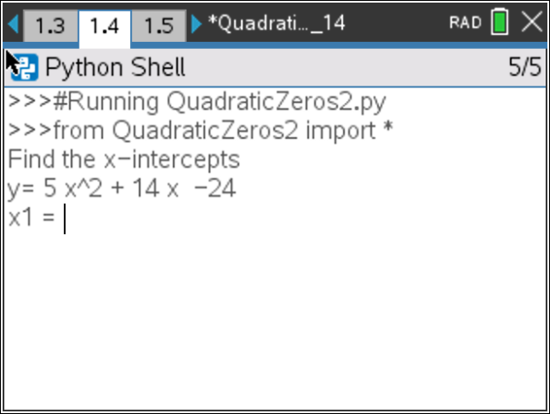
Teacher Tip:
To complete this project, students will need the base code from Integer Quadratic Zeros.
- Insert a third page into the Integer Quadratic Zeros document.  Add a python page.  Name the project QuadraticZero2 |  | 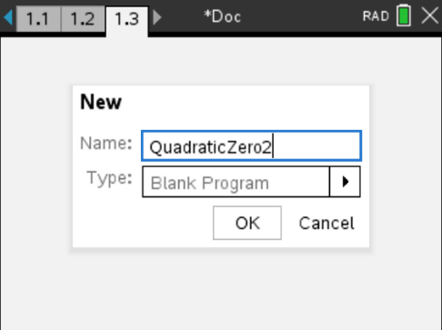
- This project will be a modification of QuadraticZero.  Go back to page 1.1.  Select all the code (ctrl -> a)  Copy the code (ctrl -> c)  Go to page 1.3, QuadraticZero2  Paste the code (ctrl -> v) |  | 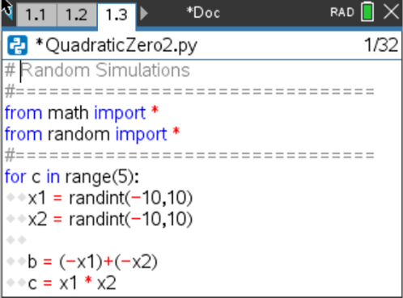
- The factored equations in this problem will be of the type:
y = ( m*x – x1 )( x – x2 )
In the first project, the line
x2 = randint(-10,10)
creates and stores random integer value from -10 to 10 in the variable x2
Similarily, we will let m be an integer value from two to seven.
Add a line of code after the x2 = randint(-10,10) to generate and store the
value of m.

- How does the addition of the cofficient m change the values of b and c in the code?
Use distribution to solve and rewrite the equation in standard form.
y = ( m*x – x1 )( x – x2 )
b = _________________
c = __________________

Modify the values for b and c in the code if necessary.
- Does your code match the code to the right? |  | 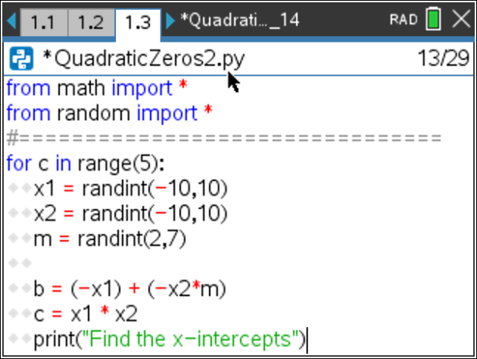
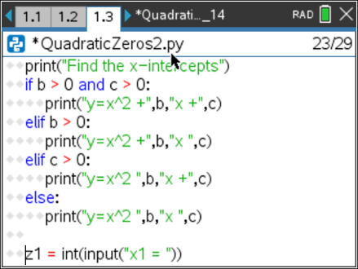
- When distributing m in step 4, your final equation started with mx^2 instead of x^2.
How can you modify the print statements to show mx^2 instead of x^2?
Be careful. You want the value of m to display not the letter m.
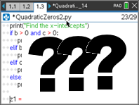
Original Modified
- How does the user input change?  Let’s look at a sample problem:  4x² + 25x - 21 = 0  (4x – 3)(x + 7) = 0  4x – 3 = 0 x + 7 = 0  x = 3/4 x = -7  Not all of the answers will be fractions, but some will be fractions.  The original code:  z1 = float(input(“x1 = “))  will not allow the user to enter the division sign.  To preform a calculation then store as a float, use the eval() function.  Modify the two input lines to:  z1 = float(eval(input(“x1 = “))  z2 = float(eval(input(“x2 = “)) |  | 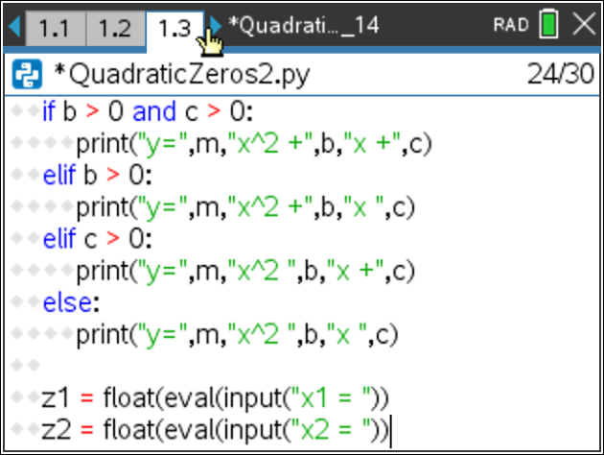
- You have one more modification to make. The original project had the line:
if (x1 == z1 and x2== z2) or (x1 == z2 and z1== x2):
Modify the if statement so it include the new coefficient m.
Execute your program. Verify your if statement works.
- Did you change the code to:
if (x1/m==z1 and x2==z2) or (x1/m==z2 and x2==z1):

- Lastly, modify your print statement if the user input is incorrect.  Original:  print(“Sorry sould be”,x1,”and”,x2)  Change To:  print(“Sorry sould be”,x1,”/”,m,”and”,x2) |  | 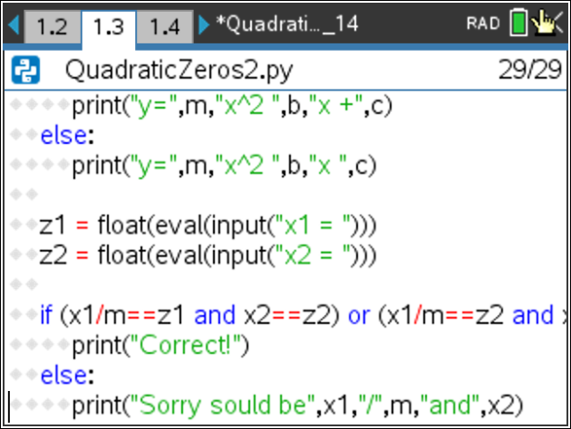
Teacher Tip:
# Random Simulations
#================================
from math import *
from random import *
#================================
for c in range(5):
x1 = randint(-10,10)
x2 = randint(-10,10)
m = randint(2,7)

b = (-x1) + (-x2*m)
c = x1 * x2
print("Find the x-intercepts")
if b > 0 and c > 0:
print("y=",m,"x^2 +",b,"x +",c)
elif b > 0:
print("y=",m,"x^2 +",b,"x ",c)
elif c > 0:
print("y=",m,"x^2 ",b,"x +",c)
else:
print("y=",m,"x^2 ",b,"x ",c)

z1 = float(eval(input("x1 = ")))
z2 = float(eval(input("x2 = ")))

if (x1/m==z1 and x2==z2) or (x1/m==z2 and x2==z1):
print("Correct!")
else:
print("Sorry sould be",x1,"/",m,"and",x2)

Challenge:
Create a QuadraticZero3 program that generates equations with two fractional x-intercepts.
For example, 6x² – 11x – 35 = 0 factors to (3x + 5)(2x – 7) = 0.
The x-intercepts would be x = -5/3 and x = 7/2.
Teacher Tip:
# Random Simulations
#================================
from math import *
from random import *
#================================
for c in range(5):
x1 = randint(-10,10)
x2 = randint(-10,10)
m = randint(2,7)
n = randint(2,7)
b = (-x1*n) + (-x2*m)
c = x1 * x2
print("Find the x-intercepts")
if b > 0 and c > 0:
print("y=",m*n,"x^2 +",b,"x +",c)
elif b > 0:
print("y=",m*n,"x^2 +",b,"x",c)
elif c > 0:
print("y=",m*n,"x^2",b,"x +",c)
else:
print("y=",m*n,"x^2",b,"x",c)
z1 = float(eval(input("x1 = "))
z2 = float(eval(input("x2 = "))
if (x1/m == z1 and x2/n== z2) or (x1/m == z2 and z1== x2/n):
print("Correct!")
else:
print("Sorry should be",x1,"/",m,"and",x2,"/",n)
print("")

