Introduction
Many situations in everyday life exhibit linear behavior. Linear behavior can be defined as a situation in which equal changes in the independent variable produce approximately equal changes in the dependent variable. For example, if data is collected for pressure versus depth underwater, each meter descended produces an approximately equal change in the pressure. This activity will help you gain a better understanding of this concept and apply it to the slope of a line.

In this activity, you will create a situation that produces linear behavior by taking distance readings as you and your classmates step heel to toe. You will then apply the properties of a linear function to develop a model for your motion. Finally, you will interpret the values used in your model.

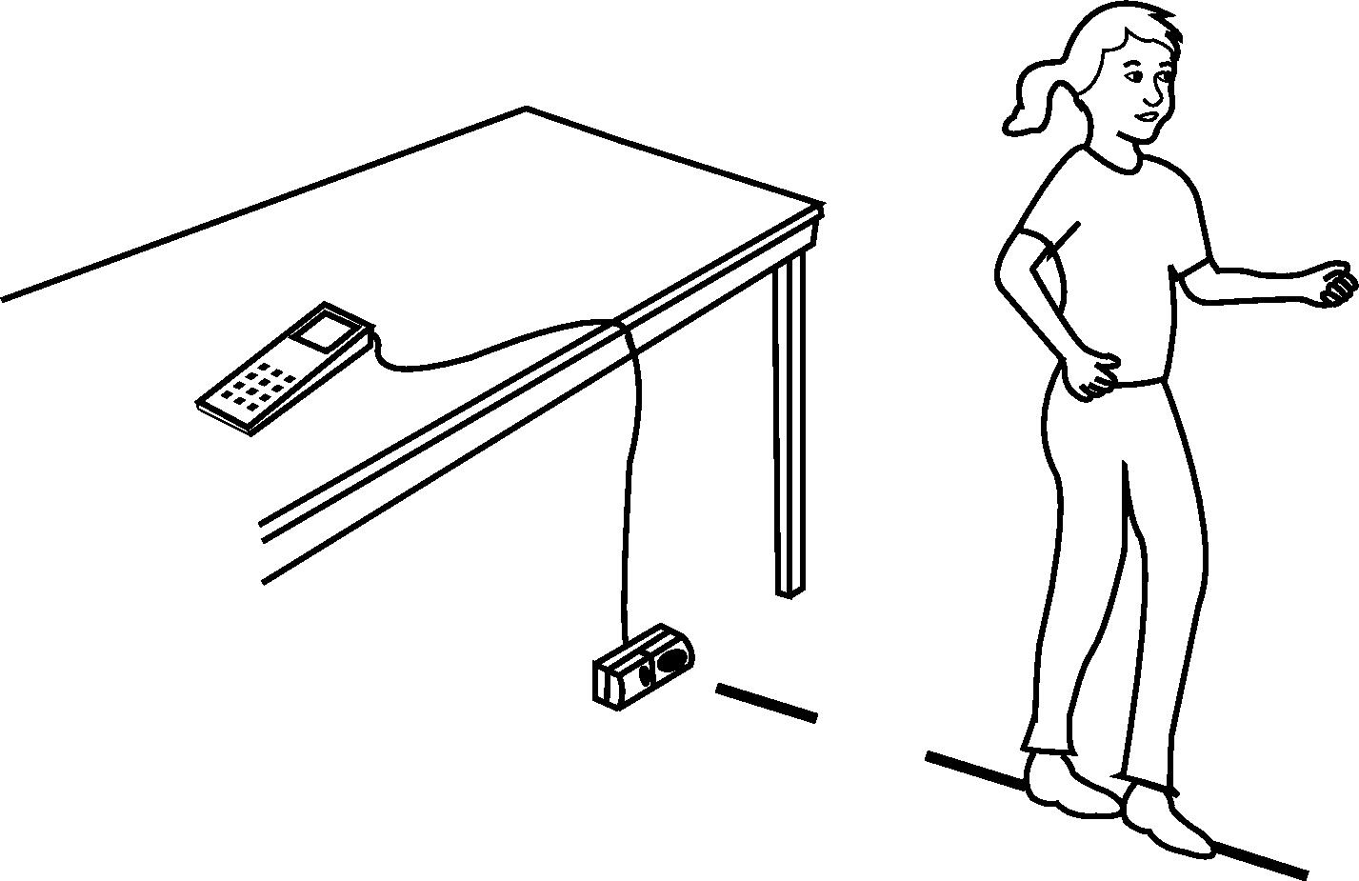

Objectives
In this activity, you will:
- Graph scatter plots
- Graph linear functions
- Calculate slope
You’ll need
- TI-84 Plus CE, with Vernier EasyData® App
- CBR 2™ motion sensor unit with mini-USB connecting cable

Using the CBR 2™ motion sensor and Vernier EasyData™ App  Connect the handheld with the CBR 2 using the USB cable. EasyData will immediately open, and the CBR 2 will begin collecting distance data every time it clicks. In the EasyData app, the tabs at the bottom indicate the menus that can be accessed by pressing the actual calculator keys directly below the tabs. | 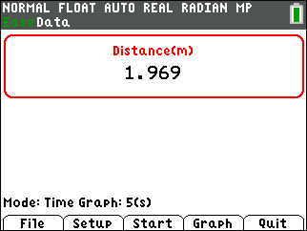  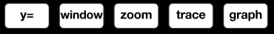

Collecting the Data
- Set up the activity as shown in the picture above. You may place the CBR 2™ on the floor o r set it on a stack of books to align with the calf of the walker.
- Link the CBR 2™ directly to the TI-84 Plus CE using the mini-USB cable.
- The EasyData App will launch automatically if you are using the mini-USB cable.  - Press o to access the File menu and select 1:New. This resets the program and clears out old data. | 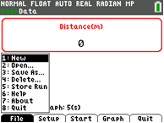
- The default unit of measurement on the EasyData App is meters. This activity will be done in feet. To change the units of measurement, select the Setup menu soft key by pressing the p key on the top row of the calculator. From the Setup menu, choose 1:Dist by pressing À or Í since 1 is highlighted. | 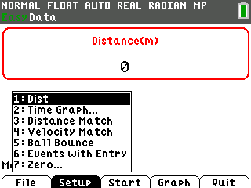
- From the Units menu, select 2:(ft) by pressing Á or by scrolling down until the 2 is highlighted and pressing Í. Then select OK. | 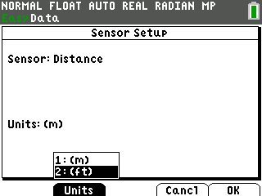
- You will be returned to the main screen of the EasyData App. Select the Setup menu again and select 6: Events with Entry. This will allow you to control when data is recorded by pressing a key on the calculator. | 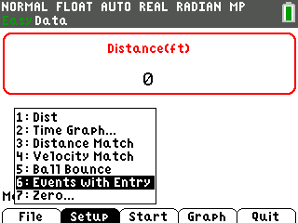
- You will be taken to a screen that displays the distance being recorded by the CBR 2 in real time. The distance to the nearest object in its path is displayed at the top of the screen. You will hear the CBR 2 clicking. Position the walker in front of the CBR 2. To record the distance for this position, select Keep. | 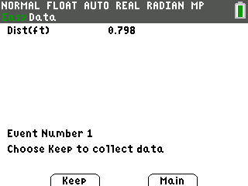
- The next screen that appears allows you to match a value with the distance you just recorded. Since this value was the first position, press À and then select OK. | 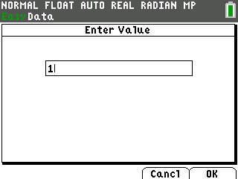
- Have the walker take a step. Repeat steps 1 and 2 until you have collected at least 6 steps. When the Enter Value screen appears, increase the value each time to represent which step you are recording. With each recorded value, a new data point will be displayed on the graph. When finished, select the Stop key. Attention should be paid to how the walker shifts his/her weight after each step and Keep should not be selected until this position is the same after each step. Inconsistent shifting of weight can introduce significant error. | 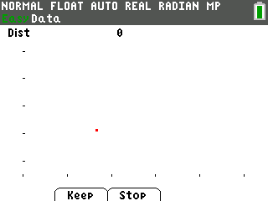
- The graph of all the data points will be displayed. You can use the right and left arrow keys to view the coordinates of the points.  - To confirm a description of the plots, select the Plots soft key. This confirmation screen will help to reinforce some of the mathematical vocabulary used routinely in the study of algebra. Identify the Events as the independent variable and the Distance as the dependent variable. | 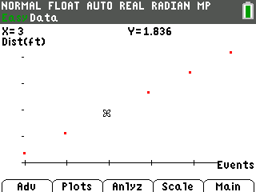
- When you select the Anlyz menu, the EasyData App will allow you to select from a variety of possible regression equations. Choose 2:Linear Fit. | 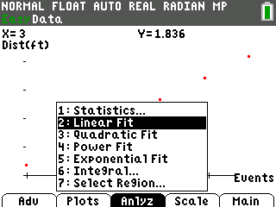
- When 2:Linear Fit is chosen, the App displays the regression equation. Select OK. | 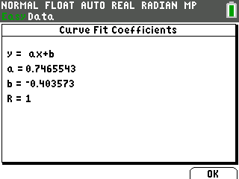
- You will see the line of best fit being drawn on the screen along with the data points.  You can still use the right and left arrow keys to scroll through the data points. To trace along the line, use either the up or down arrow key. | 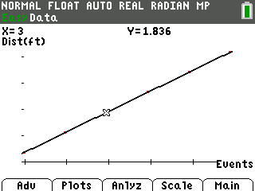
- Select Main and then Quit. The confirmation screen will be displayed so you can note the lists where your data is stored. Select OK to exit the App. | 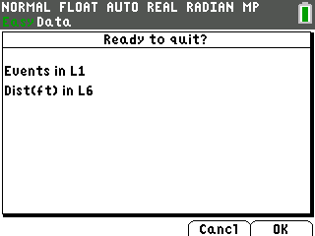
Data Analysis  - When you exit the App, the data values are stored in lists L1 and L6. Under the STAT PLOT menu, Plot1 is still turned on with the window set to display all the points collected. Y1 is turned off but the regression equation found by the App is still displayed there. You can tell that Y1 is off because the equals sign is not highlighted. This will prevent Y1 from being displayed in the graph window. | 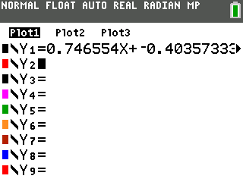
- For the calculator portion of the activity, press y o to access the STAT PLOT menu and be sure the Plot 1 is still turned on with L1 and L6 entered as the coordinates of the plot. | 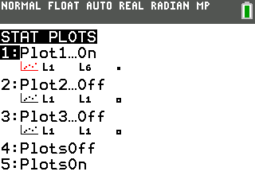
- For the calculator portion of the activity, press y o to access the STAT PLOT menu and be sure the Plot 1 is still turned on with L1 and L6 entered as the coordinates of the plot.
- Press s to see the plots. Rather than using a paper and pencil to find the slope, let the calculator do the work for you.

- Press r and use the right and left arrow keys to scroll through the points. Trace to the first point and notice the X- and Y-values.
- Press y 5. This will take you to the home screen. Press „ ¿ƒ A Í. This will store the X-value from the point you last traced on the graph screen to the variable A. Repeat this procedure to store the Y-value in B. Press ƒ Y ¿ ƒ B.  - Press s and then r. Use the right arrow key to move to the last point on the right. Once again, notice the X- and Y-values displayed at the bottom of the screen. | 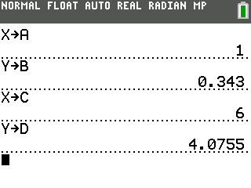
- Repeat the procedure from above to store these values in C and D. Press y 5. This will take you to the home screen. Press „ ¿ƒ C Í . This will store the X-value from the last point to the variable C. Next, press ƒ Y ¿ ƒ D. | 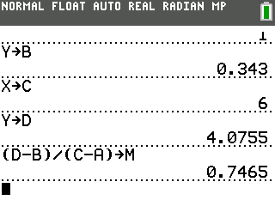
- Using the slope definition, have the calculator find the slope and store the value in M. Be sure to enclose both the numerator and denominator in parentheses. The keystroke sequence is  £ ƒ D ¹ ƒ B ¤ ¥ £ ƒ C ¹ ƒ A ¤ ¿ ƒ M Í. | 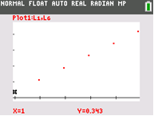
- Go to the o window and press ƒ M „ to type in MX beside Y2. Change the color of the line being graphed if you desire by pressing the | until you get to the two piece icon to the left of the equal sign and press Í. Use the | ~ to select the desired color. Then press †to highlight OK and press Í. | 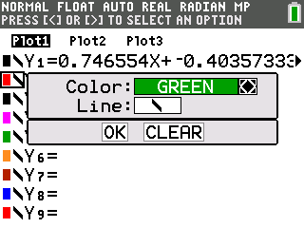
- Press s to see how closely this graph fits the points. In the example shown, it looks like the slope is correct since the line is parallel to an imaginary line through the points. The horizontal position of the line needs to be moved by adjusting the Y-intercept. | 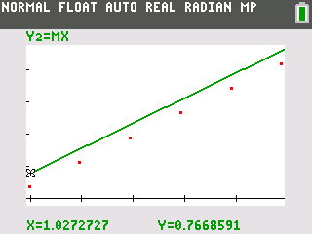
- Determine how far your line is above where the line should be. Press r You will be on the first point where X=1. Round the Y-value to the nearest hundredth and keep it in your memory. For this example, remember 0.34. | 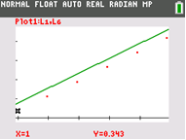
- Next, press the } key. Your cursor will jump to the middle of the line and will begin tracing along the line instead of from point to point.

- Use the | key to scroll to the point whose X-value is as close to 1 as you can get. Round the associated Y-value to the nearest hundredth and subtract the previous Y-value from it. For this set of data, the difference would be 0.77 — 0.34 = 0.43
- The line needs to move down, so the Y-intercept should be negative. Enter ¹.43 as the Y-intercept in Y2. Press s  You will see the line being drawn between the points. | 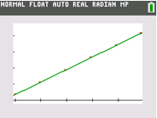
- Go back to the o window and turn on Y1. If you graph both lines at the same time it is hard to tell one line from the other | 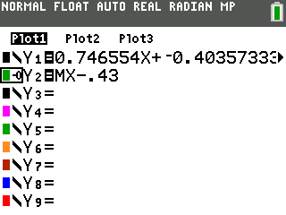
- A nice feature of the TI-84 Plus CE is the ability to change the appearance of a line. Leave Y1 with the default line but use the | key to highlight the slash icon in front of Y2. Press Í repeatedly until you see the symbol shown. The symbol looks like a ball with a line to its left. You can also change the color of the line if you desire. Highlight OK and press Í.  - Go back to the o window and turn on Y1. If you graph both lines at the same time it is hard to tell one line from the other. | 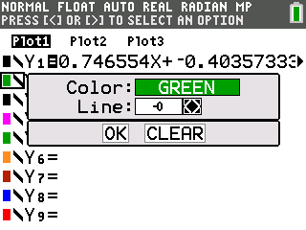
- Press s. You will see Y1 graphed with the default setting.
- After Y1 is completely graphed, you will see a small ball marking the trail as Y2 is graphed. You will easily be able to see how closely your graph matches the graph the calculator found. | 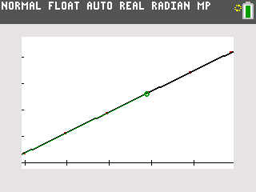
Looking at the Results
- What physical property is represented along the X-axis?
- What are the units? How far apart are the tick marks?
- What physical property is represented along the Y-axis?
- What are the units?_____ How far apart are the tick marks?
- Record the coordinates of the first data point. X =__________ Y=__________
- Record the coordinates of the last data point. X =__________ Y=__________
- What is the regression equation you found to fit the data?
- What is the regression equation found by the calculator?
- For every step taken, the distance from the CBR 2 increased by _____________.
- What is the mathematical definition of slope?
- Describe in your own words the meaning of slope in relation to this activity.
- If 20 steps were taken, how far would the walker be from the CBR 2?

