|  |  |  |  |  |
| --- | --- | --- | --- | --- |
| Six Trigonometric Functions | | | | Insert School Logo Here |
| Name: |  | Class: |  |

**Instructions:**

## Sections in *blue* font are designed for teacher notes and instructions.

## Sections in *red* font are suggested answers, again, only designed for teacher reference.

## The TI-Nspire file can be edited, items appear / disappear using ‘conditional formatting’. Change the conditions to make items appear in the order you require.

## Introduction

The three trigonometric functions sine (sin), cosine (cos) and tangent (tan) are included on scientific calculators and cover all the basic applications pertaining to right angled triangles. There are three other related trigonometric functions secant (sec), cosecant (cosec or csc) and cotangent (cot). The origins of these terms can be attributed to Arabic mathematicians. The word ‘sine’ however comes from a mistranslation of the word ‘chord’. In the unit circle sine is the measure of a semi-chord (half chord). Other terms such as cosine, cotangent and cosecant are all 90° out of phase with sine, tangent and secant as the prefix ‘co’ relates to ‘complement’.

  

Imagine your calculator had just one trigonometric ratio, let’s say: ‘sine’. It is possible to use this one ratio to generate all the others? We can see from above that cosine is easy, what about the others?

**Example**:

Suppose θ = 60°, then according to the above relationships: cos(60°) = sin(90°– 60°) = sin(30°)

## Similar Triangles

|  |  |  |
| --- | --- | --- |
| Open the TI-Nspire file “Six Trig Functions”.  Page 1.2 contains a unit circle that can be used to explore all six trigonometric ratios. The example shown opposite is for cosine, this ratio is read from the *x* axis.  Use the slider beneath ‘now showing’ to explore each of the ratios on the unit circle. Drag point P around the circle to see how each trigonometric function can be found on the unit circle. | |  |
|  | There are multiple ways some of these trigonometric functions can be displayed on the unit circle. | |
|  | To select an object where multiple items might be present, press **TAB** to move through the layers.  It is possible to hold down the click key to grab, another option is to press CTRL then click. Click or press ESC to release the grip or hold on point P. | |

Select the corresponding trigonometric function using the slider, then move point P around the unit circle. Determine the **range** of values for each function.

1. sin(θ) b) cos(θ) c) tan(θ) d) csc(θ) e) sec(θ) f) cot(θ)

**Answer:**

|  |  |  |  |  |  |  |
| --- | --- | --- | --- | --- | --- | --- |
| Function: | sin | cos | tan | sec | csc | cot |
| Range: | [-1, 1] | [-1, 1] | *R* |  |  | *R* |

Use the ‘all’ option to explore the relationship between sin(θ) and csc(θ).

**Answer**: As sin(θ) approaches zero, csc(θ) approaches ∞. As sin(θ) approaches 1, csc(θ) approaches 1. **Teacher Note**: Based on this information students should see that csc(θ) appears to have a reciprocal relationship with sin(θ).

Repeat Question 2 for cos(θ) and sec(θ).

**Answer**: As cos(θ) approaches zero, sec(θ) approaches ∞. As cos(θ) approaches 1, sec(θ) approaches 1.

**Teacher Note**: Based on this information students should see that sec(θ) appears to have a reciprocal relationship with cos(θ).

|  |  |
| --- | --- |
| Navigate to Page 2.2  The slider will adjust the problem and relevant visible components to answer each question.  The sample shown opposite illustrates two ways to look at sine. Line CP relates well to the original definition: ardha-jya where ardha translates to “half” and jya to “chord”. Line OS relates to the use on the Cartesian plane where positive and negative measurements align with computed values for sine. |  |

Show that ΔOSP and ΔOCP are congruent and hence explain how sine represents both the lengths shown.   
**Answer**: ∠COP = ∠OPS. ∠OCP = ∠OSP = 90°. (AAA)

Side OP is the common hypotenuse, therefore ΔOSP ≡ ΔOCP.

Side OS corresponds to side CP, both lengths represent sine.

Use the slider on Page 2.2 to navigate to Problem 2. Use Pythagoras’s theorem to establish a relationship between sine and cosine.

**Answer**: 

Use the slider to navigate to Problem 3 and view two ways of representing tan(θ) on the unit circle.   
Use the diagram to help show that ΔOPT≡ ΔOSQ and therefore show that the two ways of thinking about tan(θ) are the same.

**Answer**: ∠OSQ = ∠OPT and ∠TOP is common, therefore ΔOPT ~ ΔOSQ.

Side OS=1 and the corresponding side: OP=1, ∴ ΔOPT ≡ ΔOSQ  
The two representations of ‘tan’ therefore have an equivalent magnitude.

Explain how Q′ in problem 3 helps with the sign of tangent values.

**Answer**: Q′ has a y ordinate that provides the corresponding signed value.

Use the slider to select problem 4. Use triangles: ΔOPD and ΔOSP to determine the relationship between sin(θ) and csc(θ).

**Answer**: ΔOPD ~ ΔOSP since ∠SOP = ∠DOP and ∠OPD = ∠PSO, (AAA)  


Use the slider to select problem 5. Use triangles: ΔOPT and ΔOCP to determine the relationship between cos(θ) and sec(θ).

**Answer**: ΔOPT ~ ΔOCP since ∠COP = ∠TOP and ∠OCP = ∠OPT = 90°. (AAA)  


Use the slider to select problem 6. Use Pythagoras’s theorem to determine a relationship between cosecant(θ) and secant(θ), then prove the theorem to be true by writing everything in terms of sine(θ) and cosine(θ).

**Answer**: 

Use the slider to select problem 7. And determine the following:

1. csc2(θ) – cot2(θ)
2. sec2(θ) – tan2(θ)

**Answer**: Both expressions equal 1. (From the diagram)

Still using problem 7, identify an expression for (cot(θ) + tan(θ))2 then write the expression in terms of sine and cosine to show that the expression always holds.



You now have a collection of relationships between each of the trigonometric functions. Now imagine the only key that works on your calculator is the ‘sin’ key. Express each of the ratios: cos, tan, sec, csc and cot in terms of sine only over the domain: 0 ≤ *x* ≤ 90°.

**Answers**: The range of the output is different.











## Double Angle Formulas

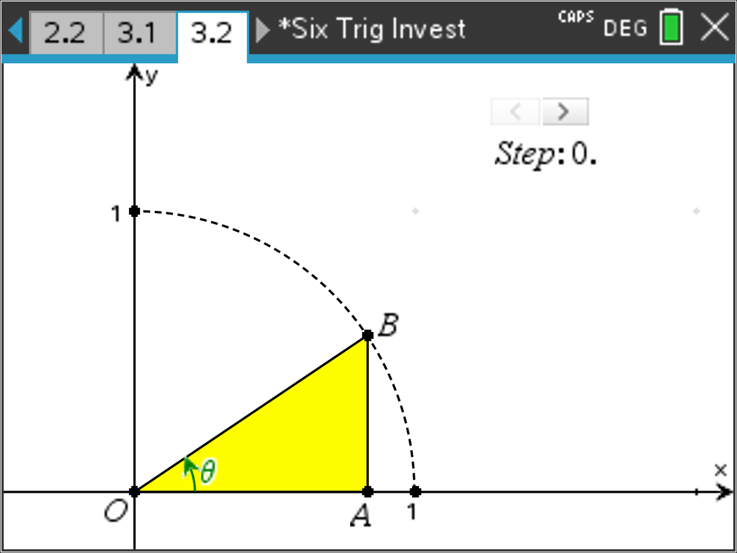Navigate to page 3.2. This page contains a dynamic diagram that will help establish a rule for sin(2θ). Use the slider to progressively display each step or clue.

Use the slider to display the initial set up “Step 0”.   
ΔOAB is such that B lies on the unit circle.   
Determine expressions for: OA, AB and OB.

**Answers:**

OA = cos(θ)

AB = sin(θ)

OB = 1 [Radius of unit circle]

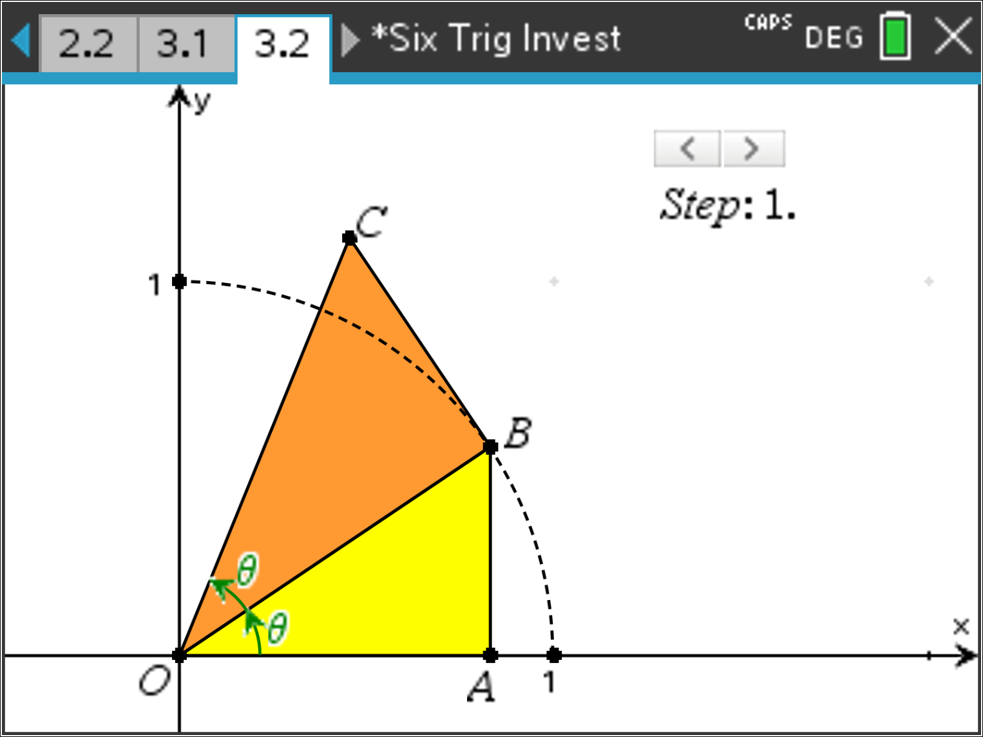Use the slider to display Step 1.   
ΔOBC is such that BC is perpendicular to OB and ∠BOC = ∠AOB   
State the reason why ΔOAB and ΔOBC are similar and hence determine expressions for: BC and OC in terms of sin(θ) and cos(θ).

**Answers:**

∠AOB = ∠BOC [Given]

∠OAB = ∠OBC [Given]

ΔOAB ~ ΔOBC





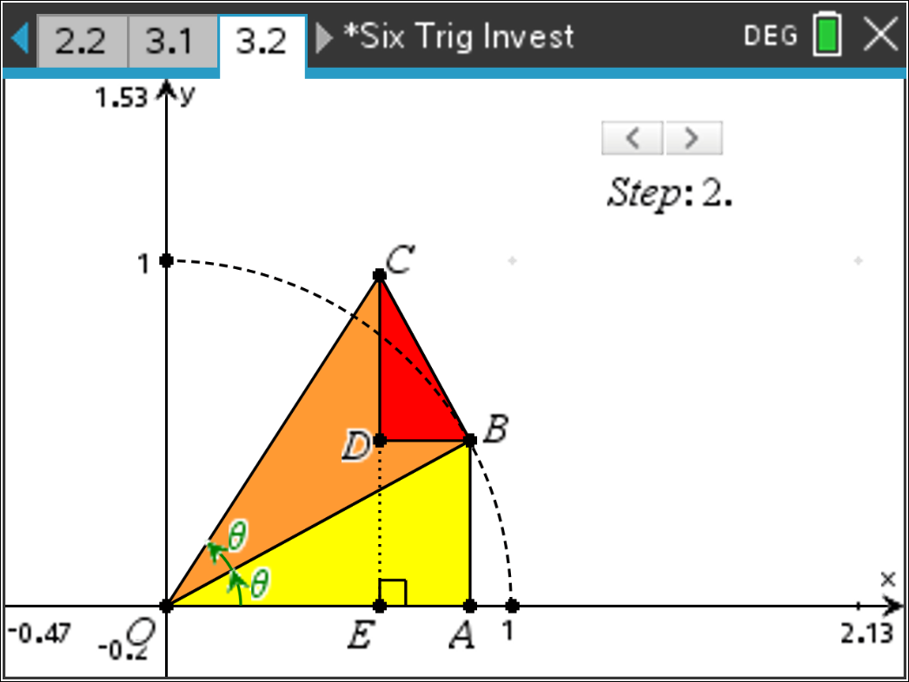Use the slider to display Step 2.   
ΔBCD is constructed such that BD is parallel to OA and ∠BDC is 90°.   
Show that ΔBCD ~ ΔOAB and hence determine expressions for CD and BD.

**Answer**:

∠BDC = ∠OAB [Given]

∠OBD = ∠BOA [Alternate angles]

∴ ∠CBD = ∠OBA

∴ AAA => ΔBCD ~ ΔOAB





1. 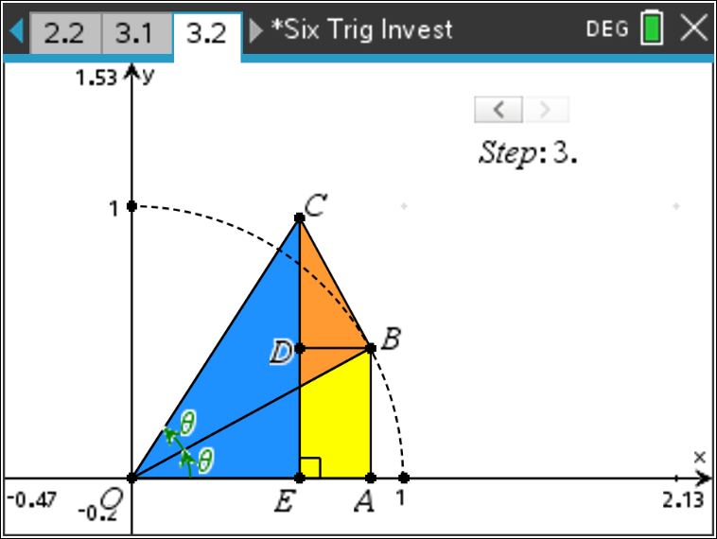

Use the slider to display Step 3.   
Use the expressions developed to write an expression for sin(2θ).

**Answer**:



Using the same diagram, show that cos(2θ) = cos2(θ) – sin2(θ).



Use your Pythagorean identity to write two other expressions for cos(2θ).

 & 

Show that 

**Answer**:

