Problem 1 – Effect of a on direct variation
Two variables are directly related if the ratio of their values always remains the same.
Equation form: y = a ∙ x
To investigate the effect the constant of variation, a, has on the graph, start the Transformation Graphing application by pressing  and selecting Transfrm and pressing .
Press □ and next to Y1 enter A∗X.  Press  and arrow over to SETTINGS. Set A = 1 and Step = 0.5. Press  and select ZStandard.  Investigate the effect A has on the graph by using the left and right arrow keys to change A. | 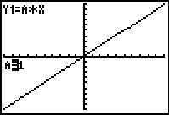
- What happens to the value of y as x increases? As x decreases?

- What do you notice about the y-intercept of the line?

- When does the direct variation line have a positive slope? A negative slope?

- For which value of a does the direct variation model not appear on screen? Why do you think this is?

- How does the constant of variation value, a, affect the graph?

Problem 2 – Application of direct variation
An example of a direct variation is how much an hourly employee gets paid. His or her total paycheck is equal to a certain wage, multiplied by the number of hours worked.
Pay = wage ∙ hours or P = w ∙ h
- In the equation P = w ∙ h, which letter represents the constant of variation?

- Rewrite the wage function if the employee is being paid $6.50 per hour.

- Rewrite the wage function for a person who earns $9 per hour.
Change the window to [0, 30] for x and [0, 300] for y. To calculate a value on the graph screen, press   and select value. Enter the x-value and press .
- Set the wage to $6.50. How much does the employee earn for 26 hours?

- The employee earned a raise to $7.50 per hour. How much will he or she get paid for 22.5 hours of work?

Problem 3 – Effect of a on inverse variation
Two variables are indirectly related if the product of their values always remains the same.
Equation form: or xy = a
Press □ and next to Y1 enter A/X.  Press  and arrow over to SETTINGS. Set A = 5 and Step = 0.5. Press  and select ZStandard.  Investigate the effect A has on the graph by using the left and right arrow keys to change A. | 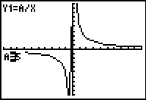
- What happens to the value of y as x increases? As x decreases?

- In what quadrants does the graph appear when a is positive? When a is negative?

- For which value of a does the inverse variation model not appear on screen? Why do you think this is?

- How does the constant of variation value, a, affect the graph?

Problem 4 – Application of inverse variation
For a salaried employee, the amount that he or she earns per hour is inversely related to the number of hours she works. He or she earns a fixed amount per week, regardless of how many hours worked.
The amount an employee earns per hour is equal to the amount earned per week divided by the weekly number of hours worked.
hourly rate =
- In the equation , which letter represents the constant of variation?

- Rewrite the rate function if the employee is being paid $900 per week.

- Rewrite the rate function for a person who earns $650 per week.

Change the window to [0, 50] for x and [0, 300] for y. Change the SETTINGS in the window menu so A = 500 and Step = 25.
- Set the salary to $775. If an employee works 45 hours during the week, how much is earned per hour?

- Jose took a day of vacation and worked only 32 hours. How much does he earn per hour if his salary is $800?

Extension – Writing a variation Equation
Determine if the graph is a direct or inverse variation. Explain how you know. Then calculate the value of a and write the equation of the graph.
1. Type of Variation:  Constant of Variation:  Equation: | 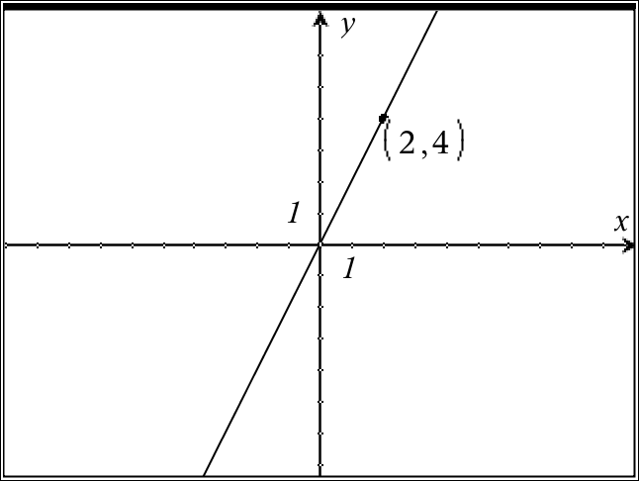
2. Type of Variation:  Constant of Variation:  Equation: | 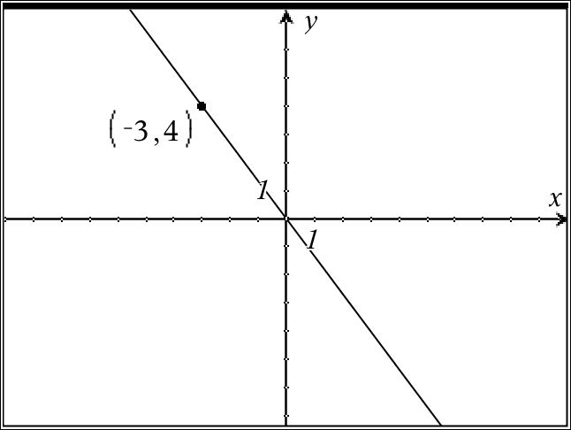
3. Type of Variation:  Constant of Variation:  Equation: | 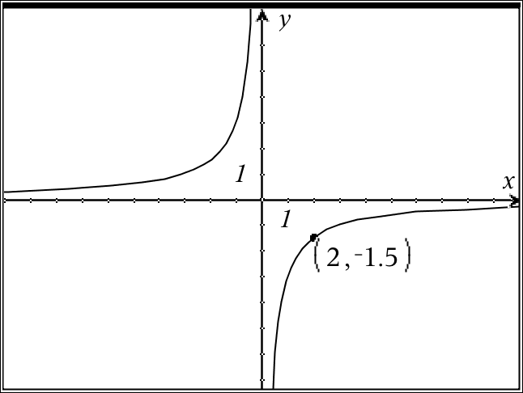
4. Type of Variation:  Constant of Variation:  Equation: | 