Open the TI-Nspire document Graph_Logarithms.tns.  This activity explores the family of logarithmic functions, where a > 0 and a ≠ 1. You will investigate the graphs of logarithmic functions and examine their general characteristics, such as end behavior, domain, and range. | 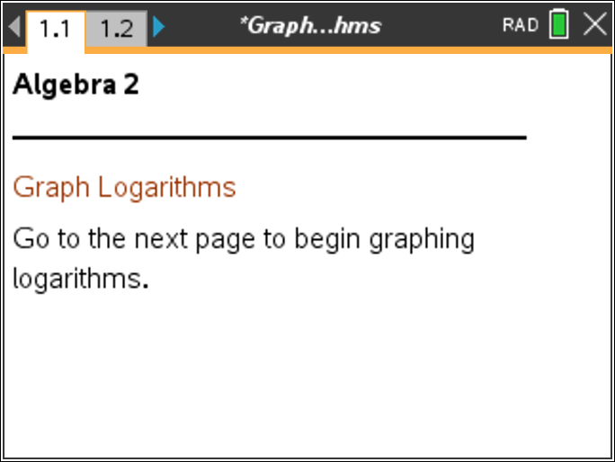

Move to page 1.2. | Press / ¢ and / ¡ to navigate through the lesson.
1. Explore several different a-values by clicking ∆ or ∇.
a. Set a = 1. Describe the graph.

b. By definition, for the logarithmic function , a cannot equal 1. What mathematical reason can you give for this restriction?

c. Set a = 0. Describe the graph.

d. By definition, for the logarithmic function , a cannot equal 0. What mathematical reason can you give for this restriction?

2. Explore several different a-values by clicking ∆ or ∇.
a. For what a-values is the function increasing? Why?

b. For what a-values is the function decreasing? Why?

3. Explore several different a-values by clicking ∆ or ∇.
a. For each a-value, identify the x-intercept of the function. Interpret your results.

b. When a > 0, why is there no y-intercept?

c. For each a-value, what part of pointremains the same? Interpret your results.

4. Explore several different a-values by clicking ∆ or ∇, such that a > 1.
a. What does f(x) approach as x approaches ? Explain.

b. What does f(x) approach as x approaches 0? Explain.

c. What is the equation of the vertical asymptote?

5. Explore several different a-values by clicking ∆ or ∇, such that 0 < a < 1.
a. What does f(x) approach as x approaches? Explain.

b. What does f(x) approach as x approaches 0? Explain.

c. What is the equation of the vertical asymptote?

6. Find the domain and range for the family of logarithmic functions where a > 0
and a ≠ 1.

7. Gail believes will eventually intersect the y-axis. Is she correct? Why or why not?

8. Judy believes has a horizontal asymptote. Is she correct? Why or why not?

