Function or Relation?  ID: 11362 | Time Required  20 minutes

Activity Overview
In this activity, students will use graphs and lists to determine if sets of data represent functions or relations.

Topic: Functions & Their Representations
- Functions vs. relations
- Graphing data using scatter plots
- Vertical line test
- Sorting spreadsheet data

Teacher Preparation and Notes
- Load the DATASET program onto student calculators.
- Problem 1 may be done in class, and problems 2 and 3 may either be done in class or assigned as homework. Questions may be recorded on the associated worksheet.
- To download the student worksheet and calculator file, go to education.ti.com/exchange and enter “11362” in the keyword search box.

Associated Materials
- FunctionOrRelation_Student.doc
- DATASET (program)

Suggested Related Activities
To download any activity listed, go to education.ti.com/exchange and enter the number in the keyword search box.
- Introduction to Graphs of Rational Functions (TI-84 Plus family) — 8075
- Functions, Relations, and Inverses (TI-84 Plus family) — 1876

Problem 1 – Voter Data
The data set for problem 1 involves the percent of the popular vote by state that was won by Democratic presidential candidates in 1980 and 1984 in races against the Republican candidate, Ronald Reagan.  Students are directed to create a scatter plot of DEM84 vs. DEM80. To set the window, students can do it manually by pressing  or use the ZoomStat command in the  menu.  Students can choose to use the box as the Mark for the scatter plot, but it might make the vertical line test harder to perform later on.  After reading the definitions of relation and function, students are asked which term they think represents the voter data.  Then, they need to decide whether to use a vertical or horizontal line to determine if a relation is a function. | 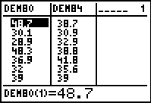  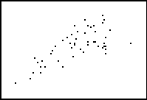
The vertical line test will be used as the first way to determine if the relation is a function. From the Graph screen, students should select Vertical from the DRAW menu.  Students can use the left and right arrow keys to move the line across the screen. Have them try to find instances where the line passes through more than one point. It should be noticeable that it fails the vertical line test in more than one place. | 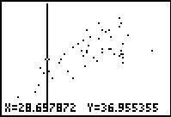
Sorting the lists is the second method students will use to determine whether the relation is a function. When using the Sort command, the first list mentioned is the independent list, and the second list mentioned is the dependent list.  Entering SortA(LDEM80, LDEM84) will sort list DEM80 in ascending order, but will keep together the data in DEM84 that corresponds with DEM80. | 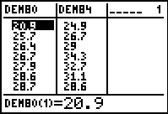
After sorting, students should see that an x-value (DEM80) has more than one y-value (DEM84).  For example, the x-value, 38.2, has two different y-values, 37.9 and 43.2.  Ask students when the list method will be more efficient and reliable than the vertical line test/graphing method. | 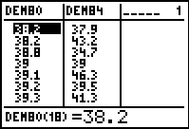
Problem 2 – Average Heights
This problem involves age and height data for children in an Egyptian village. For Problems 2 and 3, students are asked to graph the data in a scatter plot and then assess the data using either the scatter plot or the lists to determine if the data set represents a function or a relation.  Students can easily see from the scatter plot that the data set is a function. | 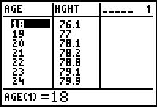  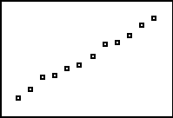
Problem 3 – Retained Impressions
This problem provides marketing effectiveness data for a variety of companies. Students will need to use the lists to determine if the data set is a function because some of the points on the scatter plot are very close together.  This data set is not a function. | 