Measuring a River
In this activity, you are part of a team building a new road. To prepare for building a bridge, you need to measure the distance across a river. The river is treacherous and impossible to cross without the right equipment, so you must measure its width indirectly, using some stakes to mark points on the bank, a tape measure, and a theolodolite. A theolodolite is a special instrument used by surveyors to measure angles. To measure an angle, the theolodolite must be placed at the vertex.
1. Brainstorm some ideas how you might measure the width of the river indirectly.  Here is one way to measure the width of the river indirectly using the tools you have on hand. Open the CabriTM Jr. file, RIVER.  Step 1: First, place a stake (plot a point) right next to your current location and label it S1.  Step 2: Now walk along the bank until you reach the proposed path of the road. Drive a stake where the proposed road intersects the river bank and label it S2.  Step 3: Use your tape measure to find the distance from S1 to S2. One unit on the diagram represents 50 ft.  2. What is the actual distance between the two stakes?  Step 4: Label the segment with its actual length.  Step 5: Set up your theodolite at S2 and measure the angle formed by the rock, S2, and S1.  Step 6: Draw the triangle formed by S1, S2, and the rock. | 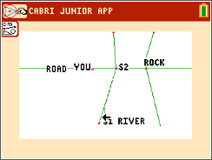
Let’s examine and prove the Law of Sines, then return to solve the problem. Follow the steps to prove the Law of Sines.  Open the CabriTM Jr. file LAWSINES.  Setting up the triangle.  Step 1: Draw an altitude H from C to the opposite side.  Step 2: Mark point D, where this line intersects CC.  Step 3: Hide the perpendicular line. | 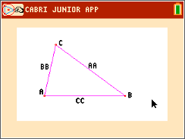
Step 4: Draw segment CD and label it H. Note that ACD is a right triangle. | 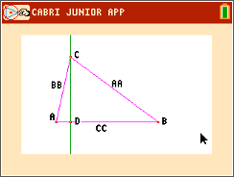
Use the triangle to write expressions for sinA and sinB using AA, BB, and H.
3. Write expressions for sinA and sinB using AA, BB, and H.

4. Solve these expressions for H and set them equal to each other to make an equation.

5. Divide this equation by (AA)(BB) to get one half of the Law of Sines.

Delete H and draw the altitude from B to the opposite side. Label it G. Now use the triangle to write expressions for sinA and sinC using AA, CC, and G.  6. Write expressions for for sinA and sinC using AA, CC, and G.  7. Solve these expressions for G and set them equal to each other to make an equation.  8. Divide this equation by (AA)(CC) to get the other half of the Law of Sines.  9. Use the Transitive Property of Equality to complete the proof. |  | 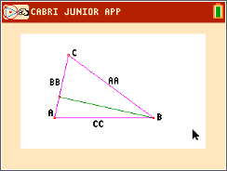
Now you can return to the river problem. (CabriTM Jr. file RIVER)
Walk back to S1 and set up your theodolite. Measure the angle formed by the rock, S1, and S2.
10. What is the measure of the angle at S1?

11. What is the measure of the angle located at the rock?

12. Use the Law of Sines to write and solve and equation to find the width of the river.

Finally, using CabriTM Jr., measure the segment from S2 to the rock.
Apply the scale factor of 1 unit : 50 feet to check your answer to Problem 12 above.

