Problem 1 – Equations of Circles
Start the CabriTM Jr. application by pressing , and then choose it from the list. Press any key to begin. Open the file EQCIRC. Press □ to open the F1: File menu, choose Open… and choose EQCIRC from the list.
In EQCIRC, you are given a circle with center at point O and the equation of the circle. Move point O by grabbing and dragging the circle. Try to determine a relationship between the coordinates of the center of the circle and the equation of the circle.
1. What relationship do you notice between the coordinates of the center of the circle and the equation of the circle?

Now, grab and move point A and try to determine a relationship between the length of the radius and the equation of the circle.
2. What relationship exists between the length of the radius and the equation of the circle?

3. What is the equation of the circle centered at (1, −2) with radius 5?

4. What are the coordinates of the center of the circle with equation (x – 4)² + (y – 5)² = 36?

5. What is the radius of the circle with equation (x – 4)² + (y – 5)² = 36?

Problem 2 – Circular Designs
Find the equation of all circles in the following four designs.
6. Face  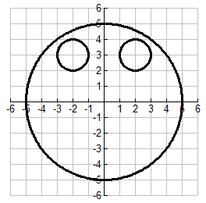 | 7. Circular Design  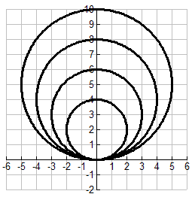
8. Snowman  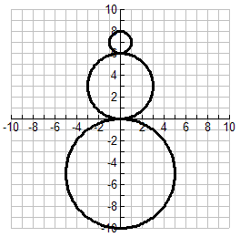 | 9. Dartboard  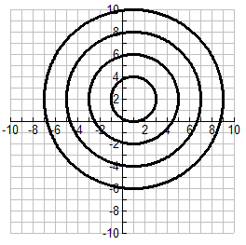
Problem 3 – Extension
10. Create your own design and find the equation of each circle used to create your design.
