Open the TI-Nspire document Solids_Disks.tns.  In this activity, you will discover how to find the volume of a solid generated by revolving the region bounded between a function, the x-axis, and x = a and x = b about the x-axis. | 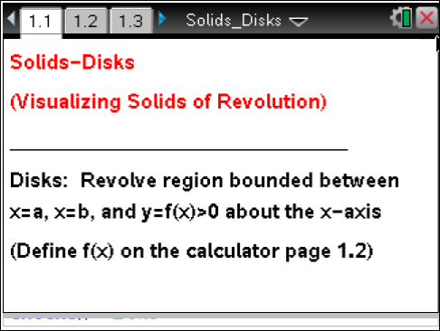

Move to page 1.3. | Press / ¢ and / ¡ or use the tabs at the top to navigate through the pages of this lesson.
1. The graph of the function between x = a and x = b has been rotated about the x-axis, generating the solid region pictured on this page.

a. Imagine you sliced through the solid region, slicing parallel to the y-axis. What is the shape of the cross section? Explain.

b. Does the shape of the cross section depend on the location where you make your slice? Explain.

c. Move point xc along the x-axis using the arrows at the left. Does this support or contradict your prediction from part 1b? Explain.

2. Use the xc arrows on the left to move to xc = 3. Suppose you slice through the solid at that point.

a. What is the shape of the cross section at that location? Explain.

b. What is the area of the cross section when xc = 3? How did you determine this?

Move to page 1.4.

3. Use the xc arrows on the left to move to xc = 3. The cross section at that point is pictured on the left.

a. How is the area of the disk at xc, shown on the left, calculated?

b. How does this compare to the area you found in question 2b? Explain.

c. How could you express the area of a cross section taken at any point x between a and b? Explain.

d. Do you think you will be able to find the area of a cross section in the same way for any function rotated about the x-axis? Explain.

Move to page 1.2.

4. Click on the screen and type in Define f(x) = and a function of your choice.

a. What do you think the solid generated by rotating your function’s graph about the x-axis will look like?

b. What do you think a cross section of the solid generated by rotating your function’s graph about the x-axis will look like? Explain.

c. What do you think the area of a cross section taken at xc = 1 will be? Explain.

Move to page 1.4.

You may have to adjust your window to get a good view of your function’s graph rotated about the
x-axis.

5. a. Were your predictions from question 4 correct? Explain.

b. How could you express the area of a cross section taken at any x-value between a and b?

6. Set a = –3 and b = 6. Place xc anywhere between a and b. Suppose that you take a very thin slice of the solid at xc, in the shape of a thin disk of thickness ∆x.

a. What is the volume of the thin disk you have sliced from the solid? Explain.

b. Imagine that you slice up the whole solid into several thin disks of thickness ∆x. How could you estimate the total volume of the solid using these disks? Explain. (Hint: Think back to Riemann sums.)

c. How could you find the exact volume of your solid? Explain. (Hint: Think back to how limits of Riemann sums were used to find areas.)

d. Will this work for any function? Explain a method for finding the exact volume of a solid of revolution.

