Problem 1 – Dilation Example
To begin this activity, two triangles with coordinates (3, 5), (7, 3), (5, 2) and (1.5, 2.5), (3.5, 1.5), (2.5, 1) must be drawn using scatter plots. Here is the procedure:
Begin by entering the following data into lists 1 through 4 by pressing … Í.  L1: 3, 7, 5, 3 L3: 1.5, 3.5, 2.5, 1.5  L2: 5, 3, 2, 5 L4: 2.5, 1.5, 1, 2.5  Notice that L1 contains the x-coordinates and L2 contains the y-coordinates for the first triangle with the first point repeated. The same pattern holds for L3 and L4. | 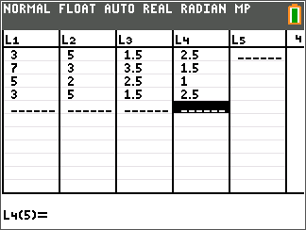
Now, set up two connected scatter plots:  - Plot 1 for L1 and L2  - Plot 2 for L3 and L4  To access the scatter plots, press y [stat plot] and select Plot1.  The settings for Plot1 appear to the right. | 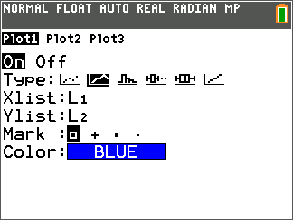
When drawing Plot2, set the marking as a plus sign. In addition to the color change, this will further distinguish the two plots. | 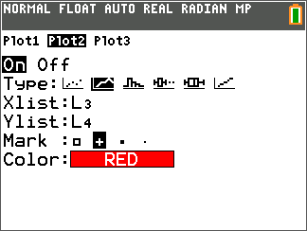
Set the viewing window by pressing p and match the settings for Xmin, Xmax, Xscl, Ymin, Ymax, and Yscl with those on screen to the right.  Once that is done, press s to view the two triangles. | 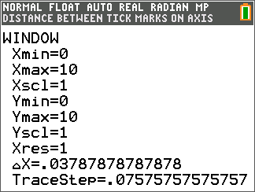
The triangle with the square vertex markings is the pre-image and the triangle with the plus vertex markings is the image under a dilation with scale factor of 0.5.  Use r to examine the coordinates of these two triangles. | 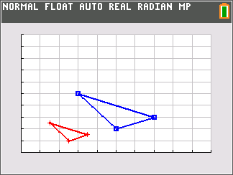
1. What do you notice about the coordinates of the pre-image and image?

A dilation matrix is created by putting the scale factor on the diagonal of the matrix and leaving all other entries as zero.
The general dilation matrix with scale factor k is: .

2. Using this information, write a matrix multiplication problem to determine the coordinates of the image of the triangle.

Problem 2 – Scaling Up or Down
Let’s explore the effect the scale factor has on our triangle whose coordinates are in Plot1.
Store the three coordinates of the pre-image triangle in matrix A by pressing y [matrix], arrowing over to the Edit menu, selecting 1:[A], and then entering the dimensions and entries of the matrix.  The screen to the right displays matrix A after the coordinates of the vertices have been entered. | 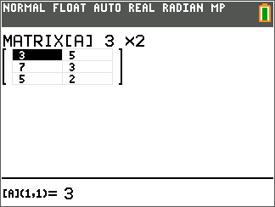
To observe the effect a k value of 2 has on the triangle, enter the dilation matrix as matrix B and then multiply [A][B] and enter these new coordinates for the image into L3 and L4. Observe the changes in the graph.  Do this with different values of k and see if there is a pattern. | 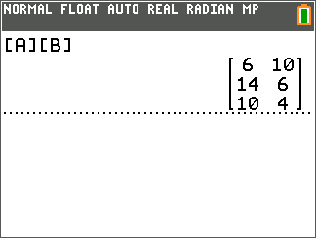
3. Write a conjecture for how the scale factor, k, determines the size of the image.

4. Using your conjecture, write a matrix multiplication problem for a triangle with coordinates
(–7, –5), (–5, 4) and (2, –6) where the image is larger. Determine the coordinates of the vertices of your image triangle. (You may need to change the viewing window to observe the new image.)

5. Using your conjecture, write a matrix multiplication problem for a triangle with coordinates
(–7, –5), (–5, 4) and (2, –6) where the image is smaller. Determine the coordinates of the vertices of your image triangle.

6. Using your conjecture, write a matrix multiplication problem a triangle with coordinates
(–7, –5), (–5, 4) and (2, –6) where the image is equal. Determine the coordinates of the vertices of your image triangle.

Problem 3 – Fencing a Garden
7. A gardener has fenced in a triangular garden with fence posts at (30, 100), (40, 0) and (0, 50). The area of the garden is 1750 square feet. After a year, the gardener has decided that his garden is too big to maintain. He now wants the size of the garden to be 1250 square feet. Help the gardener determine where his three fence posts should now be to create the garden using dilations and matrix multiplication.

