Open the TI-Nspire document Definite_Integral.  In this activity, you will use a graphical representation to explore the definite integral of a continuous function. You will change the upper and lower limits, a and b, of the integral and observe the resulting changes in the graph and the value of the definite integral. | 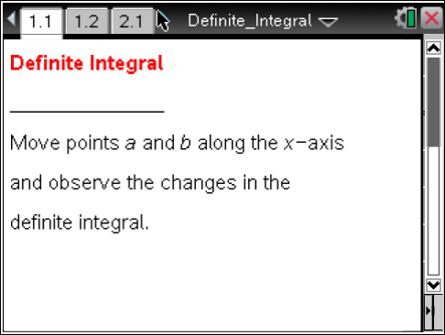

Move to page 1.2. | Press / ¢ and / ¡ to navigate through the lesson.
1. The graph shown is of the function y = f(x). The definite integral of f(x) from a to b is given by . For example, is the definite integral of f(x) from 0 to 2, or between x = 0 and x = 2.

Drag points a and b along the x-axis to determine the values of the following definite integrals, where f is the function shown in the graph.

a. =
b. =
c. =

2. Drag point a to –3 and move point b to determine the following:
a. For what values of b is positive? What do you observe about the shaded region and the graph of f when is positive?
b. For what values of b is negative? What do you observe about the shaded region and the graph of f when is negative?

c. For what values of b does = 0? What do you observe about the shaded region and the graph of f when = 0?

3. For the function f pictured on page 1.2, under what conditions of a and b in [–5, 5] will the definite integral be positive? Negative? Zero? Explain your thinking.

Move to page 2.2.

4. The graph on page 2.2 is of a new function f(x) and the definite integral . Drag point a to –3 (if a is not already positioned at –3).
a. Without dragging point b, for what values of b do you think will be positive? Negative? Zero? Explain your predictions.

b. Drag point b to test your predictions. Describe what you observed in the graph of f that confirmed or contradicted your prediction.

5. For the function f(x) pictured on page 2.2, under what conditions of a and b in [–5, 5] will the definite integral be positive? Negative? Zero? Explain your thinking.

6. Based on your observations on pages 1.2 and 2.2, for any continuous function f on an interval [c, d] and for a and b in [c, d], when will the definite integral be positive? Negative? Zero? Clearly explain your generalization.

7. The definite integral is often described as “the area under the curve y = f(x) between x = a and x = b.” What problems do you see with this definition?

