Open the TI-Nspire document Area_Function_Demo.tns.  Objective: To make a connection between the area under a derivative curve and the function that represents the antiderivative.  Directions: Follow the steps below to complete the activity. | 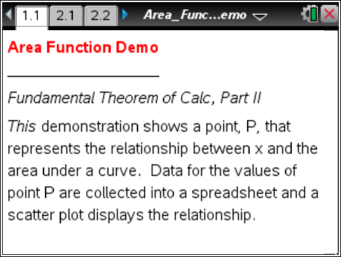

Move to page 2.1.

Example: On this page, the function graphed is f1(x) = x². The x-value of the right interval and the area under the curve from zero to the x-value are shown. Point P represents the coordinates  (x-value, area under the curve).  Move the empty circle on the x-axis and watch the tangent line and point P move. | 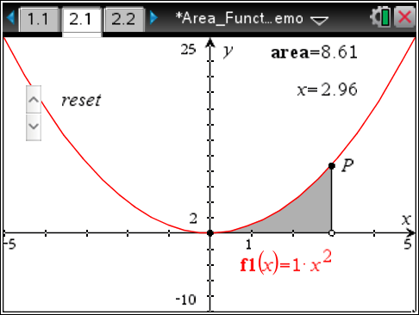
1. Can you predict what function point P is tracing?

Move to page 2.3.
You will see a scatter plot of the points that P traced on the screen.  Enter your prediction function in the entry line for f3(x) and see if your prediction matches the scatter plot. You can change the function you enter as many times as needed until you get a match.  The function that matches the scatter plot is called the antiderivative function.  2. What is the antiderivative function of f(x) = x²? | 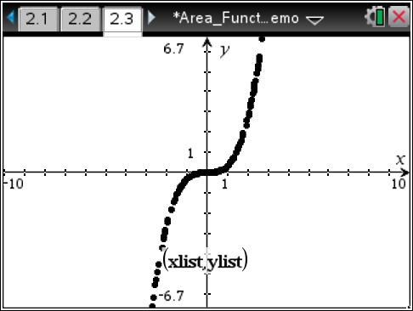
To explore other functions, use these steps to change the function and clear the collected data:  Step 1: Go to page 2.1 and change the function by clicking on f1(x) and editing the equation in the entry line.  Step 2: Go to page 2.2, highlight a cell in column A, and then select Actions > Select > Select Column.  - While column A is highlighted, hold g and press ¢ to highlight column B.  - With columns A and B highlighted, select Menu > Data > Clear Data.  Step 3: Return to page 2.1 and begin the lesson steps again. | 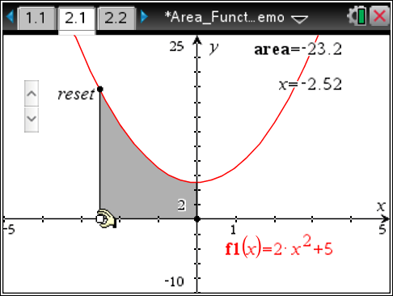  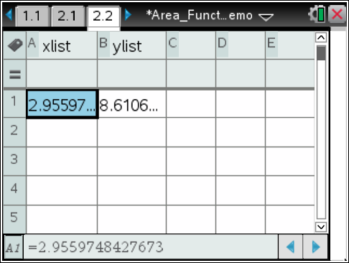
Exploration 1: Now that you have found the antiderivative function for f(x) = x², explore some other variations of this function and see if you can find a pattern in their antiderivatives.
3. Record the antiderivative functions and any patterns you saw here:
a. f(x) = ax², where a equals 2, 3, 4, etc., until you see a pattern.

b. f(x) = ax² + b; keep a constant and change b.

Exploration 2: Begin by finding the antiderivative function for f(x) = x³.
What is the antiderivative function of f(x) = x³?
Now explore some other variations of this function and see if you can find a pattern in their derivatives.
4. Record the derivative functions and any patterns you saw here:
a. f(x) = ax³, where a equals 2, 3, 4, etc., until you see a pattern.

b. f(x) = ax³ + b; keep a constant and change b.

