Problem 1 – Introduction
Use this space for notes about the discussion of the model led by your teacher.  Area of the larger square = x² +x + x + c  = x² +2x + c |  | 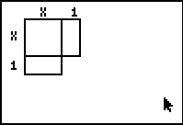
1. What is the area of the missing square that completes the larger square?

2. (x +1)(x + 1) =

Problem 2 – Integer Lengths
Start the Cabri Jr. application by pressing  and selecting CabriJr.  Open the file titled SQUARE by pressing □, selecting Open and then choosing it from the list. |  | 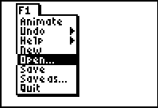
Use the  key to grab the point on the side of the square and use the arrow keys to drag it down.
Change the displayed width values to 2 and then 3. Observe the relationship between the coefficient of x, and the length of the little square that completes the (larger) square. Fill in the table as you work.
Width | (Side length)² | Area | b | c
1 | (x+1)² |  | 2 | 1
2
3

Problem 3 – Non-Integer Lengths
Use the  key to grab the point on the side of the square and use the arrow keys to drag it to change the displayed width values. Find the area of the small square and the larger square for each width value.
Observe the relationship between the coefficient of x and the length of the small square that completes the (larger) square. Fill in the table as you work.
Width | (Side length)² | Area | b | c
1.5
2.1
2.5
3.1
3.5

3. How is the coefficient of x related to the length of the small square?

4. How is the coefficient of x related to the value of c?

5. What is a formula to find the value of c?

Problem 4 – Applying your Knowledge
Answer the questions below to apply your knowledge of completing the square.
6. Area = x² + 20x + c  What is the value of c? | 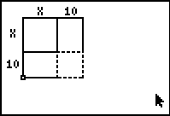
7. Area = x² + 14x + c  What is the value of c? | 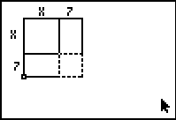
8. Area = x² + 5.4x + c  What is the value of c? | 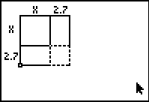
9. What is the value of c to complete a square with Area = x² +5x + c?
10 25

10. In order to complete the square, which equation will have a c-value of 8?

11. Which value below can you add to the equation x² +16x + 40 to complete the square?
8 64 24 –8

12. What must you add to the expression x² + 4x + 1 to complete the square? Why?

13. What must you add or subtract to the expression x² + bx to complete the square? Why?

