Part 1 – Birthdays in Your Class
In this problem, you will input your birthday in a class list and explore the data.
1. Write your birthday as entered in the list:
2. How many students are in your class?
3. Receive the data list back from your teacher.  Create a histogram of the whole class data set. Press ` å to set up the plot. Press @ to adjust the viewing window. Make sure each month is represented by a bar in the histogram.  4. What window is most appropriate for your data? | 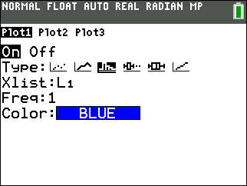
5. Draw your histogram at the right. Label the graph appropriately.  6. What does the shape of the graph tells us about the distribution of birthdays throughout the year? | 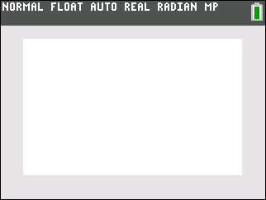
7. Now, sort L1 in ascending order. On the Home screen, press ` ò ► 1 and then ` Ω ) e. Then press S and select 1:Edit… to view L1.  Do any students share the same date? If so, how many dates are shared? | 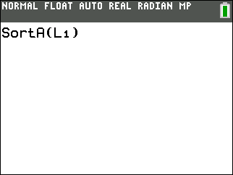
8. Did the outcome surprise you? Why or why not?

Part 2 – A 50/50 Chance of Sharing a Birthday
In this problem, you will experiment to find out many people need to be in a room to have better than a 50/50 change of two people sharing a birthday.
9. How many people do you think need to be in a room together to have a better than 50/50 chance that at least two people share a birthday? ____________ people
10. Set up your random number generator. On a clear home screen, enter the last 4 digits of your telephone number. Then press = m ► ► ► to PROB, e to select rand, then e to execute the command. | 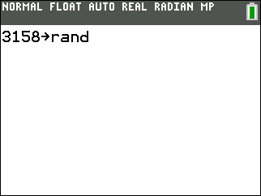
11. Enter the command randInt(1,365,1) on the Home screen and press e. To enter randInt, press m ► ► ► 5. The randInt wizard will open. Configure as shown. Highlight Paste and press e.

You’ll be taken back to the Home Screen where you will press e to get the first random number.
You will see one number between 1 and 365. Record the number below.
Continue pressing e to generate additional random numbers. Record the numbers as they are generated. Continue until you see a duplicate number. This represents a second person in the room having the same birthday as someone else.
12. How many people (random numbers) were in the room before you had a duplicate birthday?

13. Was the number you found in Question 12 greater or less than your initial estimate from Question 9?
14. Were the results from the experiment surprising? Explain.

15. After the classroom has entered their number from Question 12 in list L1, create a histogram of the data in L1. Press # 9 to graph.
Sketch the graph to the right. Label your graph appropriately.
16. Use the mean command to find the mean of the list. Press ` ò ► ► 3 ` Ω) e.
17. How does the class average compare to your estimate in Question 9? Does this surprise you? Explain.

