Open the TI-Nspire document Solids_Washers.tns.  In this activity, you will discover how to find the volume of a solid generated by revolving the region bounded between two functions about the x-axis. | 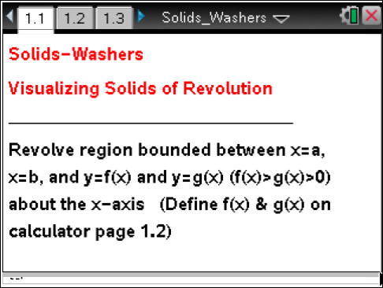

Move to page 1.3. | Use the page tabs at the top of the screen or press / ¢ and / ¡ to navigate through the lesson.
1. The graphs of the functions and are shown on page 1.3. The region between the two curves has been bound between x = a and x = b and rotated about the x-axis.
- Which function is the upper function? Which is the lower? How do you know?

- What does the solid look like? Describe its shape.

c. Imagine you sliced through the solid region, slicing perpendicular to the x-axis. What would the cross section look like? Explain.

d. Does the shape of the cross section depend on the location where you make your slice? Explain.

e. Move point xc along the x-axis using the slider. Does this support or contradict your prediction from part 1d? Explain.

2. Move point xc until it is equal to 3. Suppose you slice through the solid at that point.
a. What is the shape of the cross section at that location? Explain.

b. What is the area of the cross section when xc = 3? How did you determine this?

Move to page 1.4.

3. Move point xc until it is equal to 3. Note that the cross section of the solid at that point is pictured on the left.
a. How is the area of the washer at xc, shown on the left, calculated?

b. How does this compare to the area you found in question 2b? Explain.

c. How could you express the area of a cross section taken at any point x between a and b? Explain.

d. Do you think you will be able to find the area of a cross section in the same way for any region bounded between two functions that is rotated about the x-axis? Explain.

Move back to page 1.2.

4. Click on the screen and type in Define f(x) = and a positive function of your choice. Then type in Define g(x) = and a second positive function of your choice.
a. What do you think the solid generated by rotating your function between the x-values a = –3 and b = 6 will look like?

b. What do you think a cross section of the solid generated by rotating the region bounded by your functions about the x-axis will look like? Explain.

- What do you think the area of a cross section taken at xc = 1 will be? Explain.

Move to page 1.4.

You may have to adjust your window to get a good view of your function rotated about the x-axis.

5. a. Were your predictions from question 4 correct? Explain.

b. How could you express the area of a cross section taken at any x-value between a and b?

6. Set a = –3 and b = 6. Place xc anywhere between a and b. Suppose that you take a thin slice of the solid at xc, shaped like a washer. Call the thickness of the washer ∆x.
a. What is the smallest value xc can have? The largest?

b. What is the volume of the washer you have sliced from the solid? Explain.

c. Imagine that you slice the whole solid into washers of thickness ∆x. How could you estimate the total volume of the solid using these washers? Explain. (Hint: Think back to Riemann sums.)

d. How could you find the exact volume of your solid? Explain. (Hint: Think back to moving from Riemann sums to exact area under a curve.)

e. Will this work for any pair of functions? Explain.

