After the following five lists are transferred to your calculator, you’ll set up different types of stat plots and use the graphs to answer questions.
L1 (years from 1980 – 2004)
L2 (most home runs hit by a single player for the years given in L1)
L3 (total number of career home runs hit by the top 100 home run hitters)
L4 (number of home runs hit in 2004 by top 25 home run hitters for the American League)
L5 (number of home runs hit in 2004 by top 25 home run hitters for the National League)

Part 1 – Creating a Scatter Plot
1. Set up a Scatter Plot with L1 as the Xlist and L2 as the Ylist.  Press ` å e to access the set up for Plot1. Then, use the arrow keys and e to make selections. | 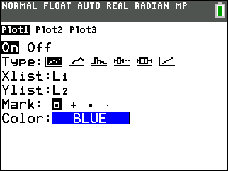
2. Press # and choose ZoomStat to display the graph. Sketch the graph at the right. Show the scale and label the axes.  3. What information can you gather from the graph? | 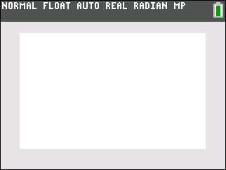
Part 2 – Creating a Histogram
4. Change Plot1 to a Histogram using L3. In the window settings set Xmin to 300, Xmax to 800, and Xscl to 50. Adjust the Y settings to see all bars.  5. How is the set up of this graph different from the scatter plot above? | 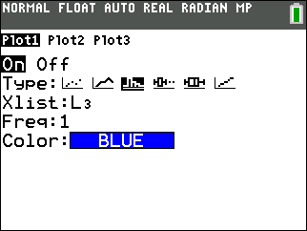
6. Sketch the graph at the right. Show the scale and label the axes.
7. What is easier to see with this type of graph?

8. What happens to the graph if you adjust the Xscl to be larger? smaller?

Part 3 – Creating Box Plots
9. Change Plot1 to a Box Plot using L4.  Set up Plot2 to a Box Plot using L5.  Press # and choose ZoomStat to display the graph. | 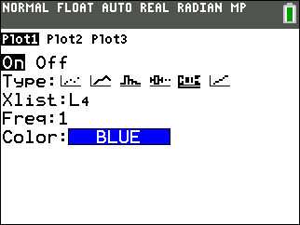
10. Sketch the graph at the right. Show the scale and label the axes.
11. Press $ and use the arrows to explore the parts of the graph. What does this graph allow you to do?

12. What can you gather from the graph?

