Introduction
Population growth can be modeled using various exponential functions.
Objective: Use two different methods to find the best model for given data.
Data: midyear world population from the years 1950-2006 (year 1 represents year 1950)
Problem 1 – Find an exponential equation by hand using two points.
In this part, you will find an exponential equation using two points. Begin observing the data.  Press  and choose WORLDPOP. When the screen displays Done, the world population data will be loaded into lists L1 and L2.  Press   to view the data.  - What kind of function would best model the data? |  | 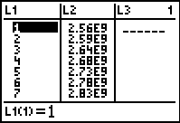
To examine the data, make a scatter plot.  Press   and select Plot 1. Adjust the settings to those shown at the right. Press  and select ZoomStat to view the plot in an appropriate window. |  | 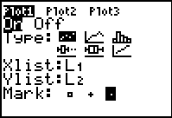
Now find an exponential model to fit the data by using two points (x1, y1) and (x2, y2). To do this, press  to see the coordinate values. Pick two points that are spread throughout the data and write the values in the space provided:
- x1 = _______ y1 = ______________________
- x2 = _______ y2 = ______________________
The general formula for an exponential function is y = a(b^{x}) where a is the initial value and b is the multiplier or in this case the growth rate.
To find the equation through the two points, first, substitute the values into the general exponential formulas:
- y1 = a(b^{x1}) ________ = ____________
- y2 = a(b^{x2}) ________ = ____________
Then divide the equations and solve for b.
________________________
- What happens to the value of a when the two equations are divided?
Subtract the exponents which are the x-values and divide the y-values using the formula .  To find the nth root on the calculator, press  and select .  - What is your value of b? | 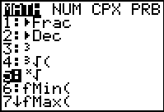
Store this value by pressing   B .
- According to your b value, by what percent is the world population growing?

Now substitute the value of b back into either of the equations above to find the value of a. Follow the steps above to store this value as A.
- What is your value of a?

- What is your exponential equation?

- Look at your equation, what is your initial population?

To graph your equation with the data, press □ and enter the expression shown at the right. Press .  - How well does your equation model the data?  - What will the population be in the year 2015?  - What was the population was in the year 1890? | 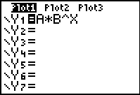

Problem 2 – Finding the exponential regression.
Now you will find an exponential regression equation to fit the data.  Press , move to the CALC menu and select ExpReg. Then enter the rest of the expression as shown at the right. | 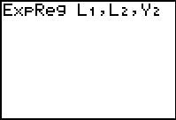
This lists the values for a and b in the general formula y = a(b^{x}).
Press % to see both equations and the scatter plot.
- What is the exponential regression equation?

- What is the initial population?

- By what percent is the world population growing?

- How do these two values compare with the ones in Problem 1?
- How well does the exponential regression equation model the data?
- What will the population be in the year 2015?

- What was the population in the year 1890?

- Which model do you feel is best? Why?

- How would you find out what year the world’s population will reach 8.5 billion people?

- Graphically use the exponential regression equation to find the year.

