Open the TI-Nspire document Long_Run.tns.  In this activity, you will explore the experimental probability of drawing a blue marble from a bag with blue and red marbles. You will also observe what happens when you repeat the process many, many times, replacing the marble each time you remove it. | 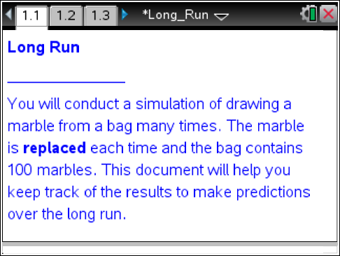

Move to page 1.2.

1. On the left-hand side of this page, grab and move the open point on the slider until the percent of blue marbles in the bag is 30%.

2. The theoretical probability of drawing a blue marble from the bag is the ratio of the number of blue marbles to the total number of marbles. What is the theoretical probability of drawing a blue marble? Explain your reasoning.

Move to page 1.3.

On this page, simulate the draw of a marble with replacement.
- Each time you select an “up” arrow, one marble is removed from the bag, the result is recorded at the bottom of Page 1.3, and the marble is placed back into the bag.
- The relative frequency of blue draws is graphed at the top of Page 1.3.
- Notice the green horizontal line—it shows the constant percent of blue marbles out of the 100 marbles in the bag. In this situation, the constant percent is 30%, which is 0.3 when written as a decimal.
3. Select the up arrow five times to draw one marble out of the bag five times.
a. What is the sequence of your first five draws? Use R for red and B for Blue.
___ ___ ___ ___ ___

b. How many blue marbles did you draw in 5 trials? (This is the frequency of blue marbles drawn in 5 trials.)

c. What is the percent of blue marbles in your simulation after 5 trials? (This is the relative frequency.)

d. Compare this percent with the total percent of blue marbles in the bag.

4. For the first five marble draws, record the relative frequency of drawing a blue marble after each draw.
____ ____ ____ ____ ____

5. Use the sequence of marbles you have drawn in the first five trials to explain the scatter plot.

6. Make a prediction of the outcome for the next 5 trials. Does the outcome depend on the results of the first 5 trials? Explain your reasoning.

7. Select the up arrow five more times.
a. What is the red-blue sequence of your second five draws? ____ ____ ____ ____ ____

b. How does the scatter plot reveal this sequence?

c. Compare the frequency of blue marbles in the first five trials with the frequency in the second five trials.

d. Compare the shape of the scatter plot for the first five trials with the shape of the plot for the second five trials. Explain any differences or similarities.

e. What is the frequency of blue marbles drawn in all 10 trials? Compare this frequency with the frequency of blue marbles in the first 5 trials (Question 3c).

f. What is the relative frequency (percent) of blue marbles in your simulation (sequence) after 10 trials? Compare this relative frequency with the relative frequency of blue marbles after the first 5 trials (Question 3b).

g. Compare this percent with the percent of blue marbles in the bag.

8. Compare your experimental results with several other students. Explain why your answers differ from others.

Move to page 1.4.

In this part of the activity, each time you select an “up” arrow, you complete 10 trials of removing one marble from the bag and replacing it before the next draw. The previous 10 trials you completed on Page 1.3 are already shown on this page. Notice the scatter plot is compressed on the x-axis.
9. Select the up arrow (nine) times to complete total of 100 trials.
a. Record the results in this chart.

Number of Trials | Frequency of Blue draws | Relative frequency
10
20
30
40
50
60
70
80
90
100

b. Describe what happens to the graph as you increase the number of trials.

c. What is the relative frequency of blue marbles in your simulation after 100 trials?

d. Compare this percent with the percent of blue marbles in the bag.

10. Compare the outcome of the experiment with 10 trials (Question 7) to the outcome of the experiment with 100 trials (Question 9). What did you observe?

11. If you were to start this experiment over and draw one marble from the bag 100 times, with replacement, would you get the similar results? Explain your reasoning.

Move to page 1.5.

In this part of the activity, each time you select an “up” arrow you complete 100 trials of drawing one marble from the bag and replacing it before drawing another one. The previous 100 trials you completed on Page 1.4 are already shown on this page. Notice the compression of the x-axis on the scatter plot.
12. Select the up arrow nine times to complete total of 1000 trials.
a. Record your results in this table.

Number of Trials | Frequency of Blue draws | Relative frequency
100
200
300
400
500
600
700
800
900
1000

b. Describe what happens to the graph as you increase the number of trials.

c. What is relative frequency of blue marbles after 1000 trials in your simulation? Compare this percent with the percent of blue marbles in the bag.

13. Compare the outcome of your experiment with 100 trials to the outcome of the experiment with 1000 trials. What did you observe?

14. Summarize the results of your simulated experiment, and complete the first row in the table below. Compare theoretical probability with experimental relative frequency for each case.

Theoretical Probability | Relative frequency after 10 trials | Relative frequency after 100 trials | Relative frequency after 1000 trials
30%

15. What is the general trend for the relative frequency of drawing a blue marble from the bag after many trials?

Move back to page 1.2.

16. Change the blue marble percentage, and repeat the experiment above with your new percentage for blue marbles. The previous results will be erased. After 10, 100, and 1000 trials, record your results in the second row of the table above.

17. Does your experiment support your earlier conclusion about the general trend for relative frequency after many trials? Explain your reasoning.

18. Allow other students to examine your scatter plots for 100 and 1000 trials. Examine their scatter plots as well. Do their experiments support your earlier conclusion about the general trend for relative frequency after 100 and 1000 trials?

