Problem 1 – Histograms and Box Plots
In this problem, you will examine the average commute times reported by different cities.
(Source: U.S. Census Bureau, 2005-2007 American Community Survey)
Using L1 from your teacher, create a histogram of the data. Press y , Í to set up Plot1 with the setting shown at the right. Then press p (at right), change the values, and press s.  1. Examine the histogram. How is the data distributed? | 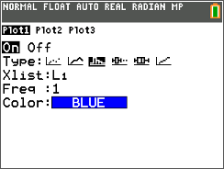
2. According to the histogram, how many cities have an average commute time between 25 and 29 minutes? | 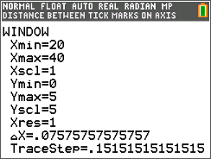
Now display the data in a box plot. Go back to Plot1 and adjust the settings as shown. Then press s.  3. What is the median commute time? Press r and use the arrow keys.  4. What is the mean commute time? Press y 9 and select mean(. Then enter L1 and press Í. | 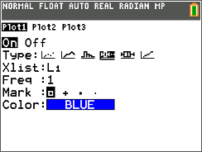
5. Are the median and mean good representations of the data? Why or why not?

6. What is the longest commute time? How do you know?

7. Which graph should be used if we wanted to know how often a certain time occurs in the data, the box plot or the histogram? Explain your reasoning.

Problem 2 – Bivariate Data
A survey was conducted at a school similar to yours. It asked 36 teachers their age and the number of years experience they had teaching. The survey results are provided in L2 and L3.
8. Set up a scatter plot as shown. What trends do you see in the scatter plot of the data? | 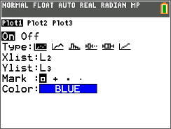
Insert a Manual-Fit line on the graph. Press …, arrow to the CALC menu, and select Manual-Fit Y=mX+b. Select Y2 to store your manual fit equation and select Calculate. Adjust it on the screen until it appears to ‘fit’ the data.
9. What is the equation of your line?

Now, insert a linear regression on the graph. Press …, arrow to the CALC menu, select LinReg(ax+b), and then enter L2, L3, Y1.  10. What is the equation of the regression line? | 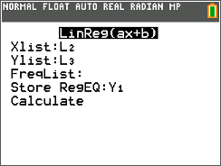
11. How does the regression line compare to the line you ‘fit’ above?

12. In this situation, what is the significance of the value for a in the regression equation?

13. What is the mean age? Use this age and the regression line to determine the number of years’ experience the “average”-aged teacher has.

14. According to the regression equation, what is the age that a teacher begins his/her teaching career?

15. Teachers are considered “retirement age” after about 30 years’ teaching experience. At what age is a teacher who is about to retire?

