It’s A Two-Way Street  ID: 11582 | Time Required  20 minutes

Activity Overview
In this activity, students will be introduced to two-way tables. They will calculate marginal and conditional distributions using formulas in a spreadsheet. This activity is intended to be followed up with teacher discussion and student interpretation of the calculations. An additional data set is provided for students to use for homework.

Topic: Categorical Data
- Two-way tables
- Marginal distributions
- Conditional distributions

Teacher Preparation and Notes
- This activity should be used in conjunction with the student worksheet. A homework problem is included. Teacher questions are included to aid in class discussion.
- This activity uses the Cell Sheet application. It should be loaded on students’ calculators before beginning the activity.
- To download the student worksheet and cell sheet data files, go to education.ti.com/exchange and enter “11582” in the quick search box.

Associated Materials
- StatWeek23_TwoWay_worksheet_TI84.doc
- TWOWAY (cell sheet data file)
- NUCLEAR (cell sheet data file)

Suggested Related Activities
To download any activity listed, go to education.ti.com/exchange and enter the number in the quick search box.
- Two-Way Tables (TI-Navigator) — 1942
- Describing Categorical Data – Advanced Placement (TI-89 Titanium) — 4352

Part 1 –Marginal Distributions
Students are given a two-way table and asked to calculate marginal distributions for each category. They may need further explanation that marginal and conditional distributions are percentages determined by the variable in question.  The sums and percentages are to be determined using formulas in the spreadsheet, TWOWAY. Students should be encouraged to discuss which numbers need to be divided to get the desired result. When using a formula, students need to be sure to use an equal sign before entering the formula. The equal sign is obtained by pressing the  key.  Discussion Questions:  - Why are two-way tables helpful as a means of displaying data?  - What do the different percentages tell us? For example, what does the marginal distribution based on party affiliation tell us? | 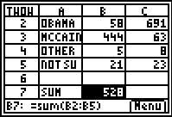  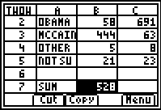  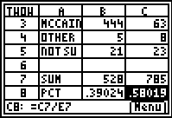
 | Party Affiliation
 | Republican | Democratic | Independent | Sum | Percentage
Obama | 58 | 691 | 20 | 769 | 57%
McCain | 444 | 63 | 16 | 523 | 39%
Other | 5 | 8 | 1 | 14 | 1%
Not Sure | 21 | 23 | 3 | 47 | 3%
Sum | 528 | 785 | 40 | 1353
Percentage | 39% | 58% | 3%

Solutions:  The marginal distribution for candidate choice says that 57% of the respondents are voting for Obama, 39% are voting for McCain, 1% are voting for candidates other than Obama or McCain, and 3% of the respondents are not sure who they are voting for. | 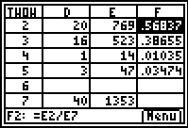

Part 2 – Conditional Distributions
Students will calculate conditional distributions. They restrict their attention to each party affiliation. Students can use any cells in the spreadsheet they want to perform the calculations. Or, they can look at their worksheet for the numbers and use the Home screen instead.  Students are to pick one box from each table and explain what the percentage represents. In the first table, for example, the McCain Democrat box means that 8% of Democratic respondents are voting for McCain. In the second table, the information in that same box signifies that 12% of respondents voting for McCain are Democrats. |  | 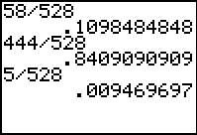  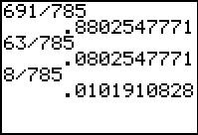
Discussion Questions:
- Restricting our attention to Republicans, what does the percentage for Obama tell us?
- Pick any of the boxes and ask for interpretations.
- How can the percents add to more than 100% in the first row of the chart?
- Now, let’s restrict our attention to Obama supporters. What does the percentage of Republicans tell us?
- Why are the conditional distributions not the same? For example, why is the percentage of Obama supporters who are Republican not the same as the percentage of Republicans who support Obama?
Given party affiliation: | Given voter choice:
   | Rep. | Dem. | Ind.
  Obama | 11% | 58% | 50%
  McCain | 84% | 8% | 40%
  Other | 9% | 1% | 2.5%
  Not Sure | 4% | 3% | 7.5%
   | Rep. | Dem. | Ind.
  Obama | 8% | 90% | 3%
  McCain | 85% | 12% | 3%
  Other | 36% | 57% | 7%
  Not Sure | 45% | 49% | 6%
Homework  Students will use what they have learned in the activity to calculate the marginal and conditional distributions for the data given on the cell sheet data file NUCLEAR. |  | 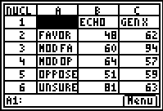

Marginal distributions:
Age |  | Opinion
Echo Boomers | 30% | Strongly favor | 22%
Gen X | 33% | Somewhat favor | 27%
Baby Boomers | 21% | Somewhat oppose | 17%
Matures | 16% | Strongly oppose | 16%
 |  | Not sure | 19%

Conditional distributions:
Given opinion:
 | Echo Boomers | Gen X | Baby Boomers | Matures
Strongly favor | 22% | 28% | 25% | 26%
Somewhat favor | 23% | 36% | 23% | 18%
Somewhat oppose | 36% | 32% | 19% | 13%
Strongly oppose | 32% | 37% | 22% | 10%
Not sure | 41% | 32% | 18% | 10%

Given age:
 | Echo Boomers | Gen X | Baby Boomers | Matures
Strongly favor | 16% | 19% | 25% | 35%
Somewhat favor | 20% | 28% | 28% | 29%
Somewhat oppose | 21% | 17% | 15% | 15%
Strongly oppose | 17% | 18% | 16% | 10%
Not sure | 27% | 19% | 16% | 12%

