Problem 1– Solving absolute value equations
You can use the properties of equality to solve an absolute value equation.
x = 4 or x = –4
Linear absolute value equations have 0, 1, or 2 solutions.
A variable expression inside the absolute value bars can be positive or negative. To solve an absolute value equation, write it as two equations and solve them.
or
or
or

You cannot use the graphing calculator to directly solve absolute value equations, but you can use it to check your answers. To check the solutions x = 4 or x = –4 for |x| + 6 = 10, first press    to store 4 as x. | 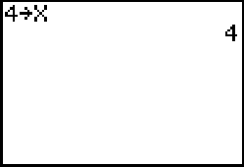
Then test the equation. The abs( command is found in the MATH > NUM menu, and the equals sign is found in the TEST menu. If the calculator returns a value of 1, the equation is true for the current value of x. If the calculator returns a 0, the equation is not true for the current value of x. | 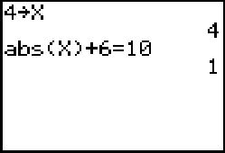
Check the solution x = –4.  - Check the solutions x = 6 and x = –4 for  |x – 1| = 5. | 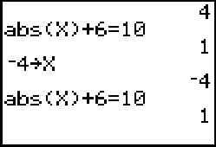

Exercises
Solve each equation. If there is no solution, write no solution. Check your answers.
1. |x| + 5 = 7 | 2. |x – 8| = –5 |  | 3. 2|x| + 3 = 11 |  |  | 4. |x + 2| = 6
5. |x| – 8 = –3 | 6. |x + 2| = 0 |  | 7. |3 – x| = 9 |  |  | 8. |2x – 3| = 7
Problem 2 – Absolute value inequalities
You can write absolute value inequalities as compound inequalities. To see this, graph some absolute value inequalities in a single variable.
Run the program ABSINEQ and enter |x – 1| < 3. To do so, enter abs(x–1) as the left side, 3 as the right side, and choose < as the inequality sign. Then choose View Graph to graph this inequality.
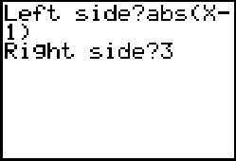 |  | 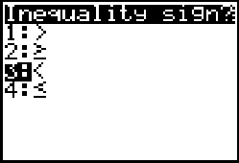 |  |  | 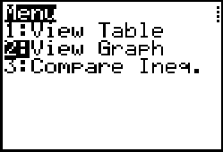
Examine the graph. |x – 1| < 3 means all numbers less than 3 units away from 1, so –3 < x – 1 < 3.  Caution: In some graphs, the open circle will appear to be filled in. This is because of the size of the pixels on the graph screen. For this reason, a “closed circle” is shown as a cross, and an “open circle” as a open or closed square. |  |  |  | 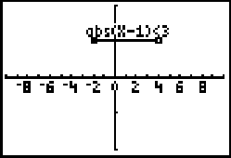
Press  to exit the graph screen and  to run the ABSINEQ program again. Use the calculator to graph |x – 1| > 3.
The inequality |x – 1| > 3 means all numbers more than 3 units away from 1, so x < –2 or x > 4. In general, by looking at the inequality sign, you can choose how to write an absolute value inequality as a compound inequality. |  |  |  | 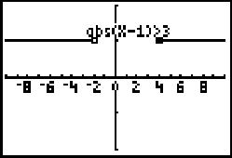
Rules for absolute value inequalities
Rule 1 An inequality of the form |A| < b is  equivalent to –b < |A| < b. |  |  | Rule 2 An inequality of the form |A| > b is  equivalent to A < –b or A > b.
Rule 3 An inequality of the form |A| ≤ b is equivalent to –b ≤ |A| ≤ b. |  |  | Rule 4 An inequality of the form |A| ≥ b is  equivalent to A ≤ –b or A ≥ b.
Exercises
Match each absolute value inequality with an equivalent compound inequality.
1. |x| < 3 |  |  | a. x < –6 or x > 6
2. |x| > 6 |  |  | b. x + 18 ≤ –12 or x + 18 ≥ 12
3. |5x| ≤ 30 |  |  | c. –3 < x < 3
4. |x + 18| ≥ 12 |  |  | d. x < –2 or x > 2
5. |x| < 6 |  |  | e. –6 < x < 6
6. |x| + 2 > 4 |  |  | f. –30 ≤ 5x ≤ 30
Write each absolute value inequality as a compound inequality.
7. |x + 7| > 9 | 8. |3x| ≤ 6 |  | 9. |x| – 3 > 7 |  |  | 10. |2.5x| < 4

Problem 3 – Solving absolute value inequalities
Sometimes it is necessary to simplify the absolute value inequality before writing it as a compound inequality.
4|x + 1| < 16
$$\frac{4\left|x+1\right|}{4}<\frac{\text{16}}{4}$$
|x + 1| < 4
–4 < x + 1 < 4
–4 – 1 < x + 1 – 1 < 4 – 1
–5 < x < 3

You can graph absolute value inequalities to check your answers. Compare the graph of the original (unsolved) inequality with the solution.  - Use the ABSINEQ program to graph 4|x + 1| < 16 and compare its graph with the solution given above. |  |  | 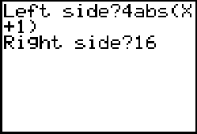
Exercises
Solve each inequality. If there is no solution, write no solution. Check your answers.
1. |x + 8| ≥ 3 | 2. |x – 2| ≤ 1 | 3. |x – 3| ≤ 4 |  | 4. |2x – 5| > 9
5. |2x – 3| ≥ 7 | 6. |x + 2| > 0 | 7. |3 – x| < 9 |  | 8. –3|x + 2| > –12

