Part 1 – Is it a triangle?
Adrienne is making a mobile of triangles for a geometry project. She will use straws from 1 inch to 6 inches (whole number lengths only) for the sides and twist ties to connect them. She wants to make sure she uses all the possible sizes of triangles in her mobile.
To help Adrienne, you are going to play a game to determine if three numbers can be the sides of a triangle. Play with your partner and complete the following table. The player with the greatest difference between the “Is A Triangle” column and the “Not A Triangle” column wins.
1. Use the randInt( command to randomly find three digits between 1 and 6. Take a straw and cut lengths to match the numbers rolled. Then, try to make a triangle with the given sides.  If you can make a triangle, record the sides in the appropriate column. If you cannot make a triangle, record the side lengths in that column. After 10 times, find the difference between the number of triangles made and not made to determine the winner. | 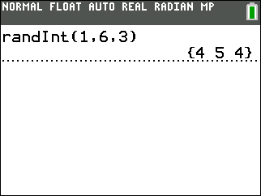
 | Player 1: |  | Player 2:
Trial | Not A triangle | Is A Triangle | Not A Triangle | Is A Triangle
1
2
3
4
5
6
7
8
9
10
Totals
 | Player 1 Total |  | Player 2 Total

2. What conclusions can you draw about the lengths of sides of triangle and when they form a triangle?

3. Give an example of a set of 3 numbers (different from those in the table above) that could be the sides of a triangle.
4. Give an example of a set of 3 numbers (different from those in the table above) that could not be the sides of a triangle.
5. Go back to Question 1 and classify the triangle as equilateral, scalene, and isosceles, by writing an E, S, or I next to each row.
6. Go back to Question 1, look at the angles in the triangles you created. Classify the triangles as right, acute, or obtuse. Write an R, O, or A next to each row.
7. Why can’t a right triangle have two right angles?

8. An equilateral triangle is said to also be equiangular. What is the measure of each angle in an equilateral triangle?
In a right triangle, the square of the hypotenuse (longest side) is equal to the sum of the squares of the other two sides. This important theorem is called the Pythagorean Theorem. A set of numbers that satisfy this equation a² + b² = c² is called a Pythagorean triple.  Test 3, 4, and 5 in this equation to see if it is a Pythagorean triple. Press 3 = a A e a :. Repeat to store 4 to B and 5 to C.  Next enter both sides of the equation as shown. Press a A q + a B q e. Then enter C² and press e . | 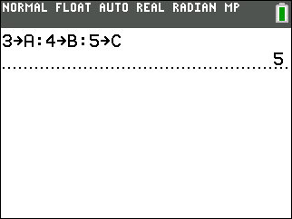  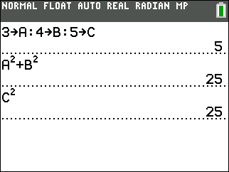
9. Does the 3, 4, 5 triangle appear to have one right angle and two acute angle?
10. Using an acute triangle, evaluate the equation. It is okay if a = b.
a (shortest side) = ____ b (middle side) = ____ c (longest side) = ____
Fill in the box with <, >, or =. a² + b² c²
11. Repeat using a right triangle.
a (shortest side) = ____ b (middle side) = ____ c (longest side) = ____
Fill in the box with <, >, or =. a² + b² c²
12. Repeat using an obtuse triangle.
a (shortest side) = ____ b (middle side) = ____ c (longest side) = ____
Fill in the box with <, >, or =. a² + b² c²
13. Compare your results from Questions 10 – 12 and make a conjecture from your experiment.

Part 2 – How Many Triangles?
Now, use the information from the first part of this activity to make sure you find all the possible triangles.
14. Combine all the data generated by the class into one table. List all triangles with the side length given in the first column. If there are triangle sizes that were not found during the game, include it now.
A triangle with sides 332 would NOT be included in the 3 inch side row because it was already included in the 2 inch row (233). Do not repeat triangles.
All Triangles  with side(s) | List Triangles | Total
of 1 inch
of 2 inch
of 3 inch
of 4 inch
of 5 inch
of 6 inch

15. How many triangles would Adrienne need to make for her mobile?

