Problem 1 – Exploring Values of b and c
Start the Transformation Graphing application by pressing Œ and selecting Transfrm.  Now, press o and enter the general quadratic AX²+BX+C into Y1 for f(x) = ax² + bx +c. |  |  |  |  |  | 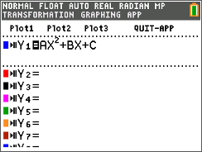
Press p and the up arrow to change the step size to 1.  Press q and select ZStandard. Notice the displayed quadratic equation. The values of B and C may be changed by using the arrow keys or type a number and press Í. |  |  |  |  |  | 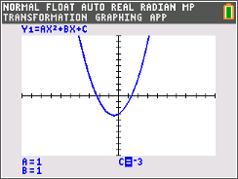
To calculate a zero, you will need to press yr and choose zero.  - Move the cursor to the left of the zero and press Í.  - Move to the right of the zero and press Í.  - Move to your best guess for the zero’s location and press Í. |  |  |  |  |  | 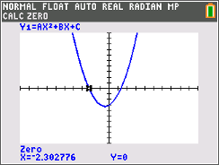
Your goal is to choose different values for B and C that result in the graph crossing the x-axis once, twice, or not at all. (A solution to the equation f(x) = 0 is called a zero of the function). Record your results in the table below.
Note: Do not change the value of A.

 | A, B, C values
 | Number of real zeros
 | Zero values
1. When does the function have two zeros? One zero? No zeros?
- 2 zeros:
- 1 zero:
- no zeros:

2. How does the number of zeros relate to the number under the square root?
- 2 zeros:
- 1 zero:
- no zeros:

3. When does the function have zero(s) that are rational? Irrational? Not real? (Relate the type of zero to the number under the square root.)
- rational:
- irrational:
- not real:

4. Give a function that has the following type of root(s). Avoid using 0 for B and C.
- 2 real, rational roots:
- 2 real, irrational roots:
- 1 real, double root (rational):
- no real roots:

Problem 2 – The Quadratic Formula
The quadratic formula for f(x) = ax² + bx + c can be used to determine all roots. It is particularly useful when trying to find irrational and imaginary roots.
5. Use the quadratic formula to find the exact value of the zeros of f(x) = x² + 3x – 1. What are the values of a, b, and c?

6. By hand, use the quadratic formula to find the imaginary zeros of f(x) = x² – 2x + 2. Show your work. Remember that .

Confirm your answer using the graphing calculator. Remember to set the graphing calculator to imaginary mode by pressing z and matching the screen to the right.  You will also need to calculate the – and + of the quadratic formula separately. |  |  |  |  |  | 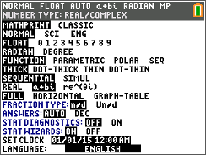
Problem 3 – Exploring the Value of a
Press s and change the values for A.

7. In Problem 1, A was set equal to 1. Do your conclusions from Problem 1 still hold if A ≠ 1?

Problem 4 – Exploring Other Rational Numbers
A, B, and C can equal values other than integers. Change A, B, C to non-integer values and investigate the effect on the graph.
8. Do your conclusions from Problem 1 remain the same if a, b, and c are not integers?

9. Why do some decimals under the square root, like 12.25, make the zeros rational, but other decimals make the zeros irrational?

