Problem
Games and More, Co. produces both video and DVD game players. Each video player, Gamer Gallery, requires 1.5 hours for assembly and 0.25 hours for testing. Each DVD player, Major Player, requires 1 hour for assembly and 0.5 hours for testing.
Each month, the Games and More manufacturing plant has 45,000 available hours for product assembly and 20,000 available hours for product testing.
Games and More, Co. earns $60 profit from each Gamer Gallery and $75 profit from each Major Player that it sells.
How many of each type of player should the Games and More, Co. produce in order to obtain the greatest monthly profit? You can use linear programming to solve this manufacturing problem.
Let x be the number of Gamer Gallery players, and let y be the number of Major Players.

- Write an expression that represents the profit earned from selling the two different players. This is called an objective function.
P(x, y) =

- Determine the profit that would be earned if 50 Gamer Gallery players and 100 Major Players were sold.

- Write a system of inequalities that represents the constraints for the problem.
Assembly time constraint:

Testing time constraint:

Non-negative number of Major Player and Gamer Gallery players:

Turn on the Inequality Graphing Application. Press   ○ to skip to the I's, then press . | 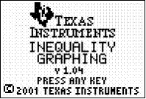
Press any key to continue. This will take you to a modified □ screen. The five symbols along the bottom can be accessed by pressing  followed by the appropriate function key. To enter an inequality in terms of x arrow to the top (X=) and press . | 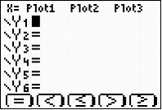
Enter the four inequalities in linear function form. Three can be entered on the Y= screen. Use  to highlight X= in the top left corner. Press  and enter the final inequality.
Press  and set the settings as shown, and then press . | 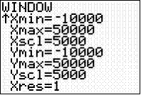
- Find the vertices of the feasible region. Use the Shading feature to show the feasible region. Press  [F1] and select Ineq Intersection. Use the Point-of-Intersection Trace (PoI-Trace) to find the coordinates of the vertices. Press  [F4] and use the arrows to move the cursor. Record the vertices in coordinate pair form.

- Substitute the coordinates for each vertex into the profit expression (objective function) to find the maximum profit.
P(x, y) =
P(x, y) =
P(x, y) =
P(x, y) =
- Based on these results, how many of each type of player results in the maximum monthly profit for Games and More Company? What is the maximum possible monthly profit?
Gamer Gallery Players:

Major Players:

Monthly Profit:

