Consider the equation y = x² + x – 15. Press □ and enter the equation as shown. | 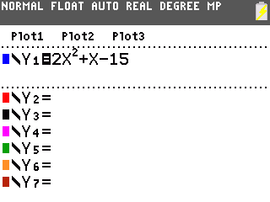
Press . Take a moment to examine the graph. It would be helpful to be able to see the vertex. Press  and adjust the window to show more space below the x-axis. Press . | 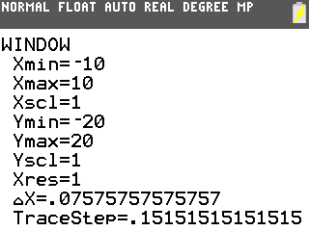
- Approximately where is the vertex of the parabola?

- What do you notice about the shape of the parabola?

The symmetry of a parabola should mean that for every value of y that the parabola takes on, there are two values of x that are paired with it. Press  . Examine the table and notice that there are no repeated values of y. Try adjusting the table set up to view more values of x. Press   and set the “change in table” to 0.5 as shown here. | 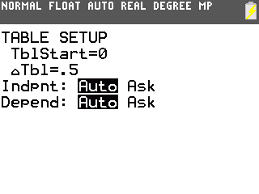
Press  . Now, as expected, each y value is associated with two x values. Choose a pair of x-values that have the same y-value.  Press   to go to the Home screen. Average the two x-values by adding them together and then dividing the sum by 2. | 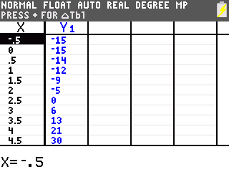
Return to the table. Choose another pair of x-values that have the same y-value.
Press   to go to the Home screen. Average the two x-values.
- What do you notice about the two averages so far?

- What significance might this number have?

- Using either factoring or the quadratic formula you should (or will) be able to find two x-values that have the y-value of zero for many parabolas.  Choose the two x-values that represent the zeros of this parabola using the table or another method. | 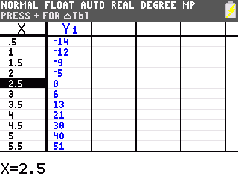
Return to the home screen. Average the two x-values.
- What do you notice about these three averages? What significance might this number have?

Think about what it means to average two numbers on a number line. The average is the point halfway in between the numbers.
- If you fold the parabola and match up the symmetrical parts, what would be the point on the fold, or halfway in between?

To see what the significance of the value x = –0.25, examine the graph. Press . Press . In “trace” mode, type    •. Press .  - What point on the parabola have you found? | 